

BRIGHTWAY
INSURANCE
2022

OFFLINE CANCELLATION GUIDE

Contents
OFFLINE CANCELLATION GUIDE 1
HOW TO PROCESS CANCELLATION EMAILS/SUSPENSES 5
Contacting the Customer 8
Information Provided in the Email or by Phone 10
Cancelling Electronic Funds Transfer 19
When signed cancellation request and other required documentation are received 21
Email System; Processing Cancellations 22
Cancelling a policy in AMS 29
Cancellation Suspenses 31
What is an Attempt? 33
Locating documents for cancellations 35
Outbound Mail Procedure 36
Carrier Navigation Guides 43
Aegis 43
All Risks Limited 44
Allied/Nationwide 46
Auto Cancellation Process 47
American Bankers Insurance of Florida 49
American Colonial Insurance 51
American Integrity Insurance 51
American Strategic Insurance (ASI) 53
American Summit Insurance 53
American Traditions Insurance Company 53
American Traditions Flood 55
Americas Insurance 55
Anchor Homeowners – LA Premier 55
Anchor Homeowners – TX Premier 55
Anchor Homeowners – TX Silver 55
Anchor Insurance 55
Assurant Flood/Sunshine 58
Avatar Property and Casualty 58
Bankers Insurance Company 61
Bankers Flood 65
Bristol West Insurance 67
California Fair Plan Homeowner 69
Capitol Preferred Insurance Company*, Cypress Property & Casualty*, Edison Insurance Company*, United Property & Casualty*, Southern Fidelity Insurance* 69
Citizens Property Insurance Company 71
Dairyland Insurance 75
Edison Homeowners *Duck Creek System* 75
Encompass Insurance 75
Excalibur Homeowners 77
Federated National Insurance 77
Florida Family Insurance 78
Florida Family Flood 79
Foremost Insurance Company 79
Frontline Insurance 80
Frontline Flood 82
GeoVera Specialty Insurance 82
Germania Homeowners 82
Grundy Worldwide 83
Gulfstates Homeowners 83
Gulfstates Flood 83
Gulfstream Flood 83
Gulfstream Homeowner 83
Hagerty Insurance 83
Hartford Insurance 86
Heritage Property and Casualty Insurance Company 86
Hippo Insurance 87
Homeowners Choice Insurance 87
Homeowner’s of America 87
I.B. Green & Associates Insurance 88
Infinity Insurance (Kemper Personal and Specialty) 89
Auto Cancellation Process 91
Kansas Fair Plan 93
Lighthouse Homeowners 93
Lighthouse Flood 94
Maison Homeowner 94
Maison Flood 94
Mercury Insurance Group 94
Narragansett Bay Homeowners 96
National General Insurance 96
Auto Cancellation Process 98
Neptune Flood 100
NFIP Insurance 100
Olympus Homeowner 100
Olympus Flood 102
Peoples Trust Insurance Company 102
Prepared Homeowner 105
Prepared Flood 106
Progressive American Insurance Company 107
PURE Flood 107
Safepoint Insurance 107
Safe Harbor Insurance Company 107
Safeco 109
Auto Cancellation Process 109
SageSure Homeowner 110
SageSure Flood 110
Seacoast Brokers Insurance 110
Security First 112
Ski Safe Watercraft 114
Southern Insurance Underwriters 114
Southern Oak Insurance Company 114
Stillwater Homeowner 117
St. Johns Insurance Company 117
State Auto 118
Tapco Insurance 118
Texas Fair Plan 118
The Hartford 119
Auto Cancellation Process 119
Tower Hill Insurance 120
Travelers 122
TypTap Insurance 122
Universal Insurance Company of North America 123
Universal Property and Casualty 125
Velocity Risk Underwriters 127
Wellington Insurance 128
Weston Insurance 128
Windhaven Insurance 128
Wright Flood 128

HOW TO PROCESS CANCELLATION EMAILS/SUSPENSES

Email Transaction

If the customer is emailing in to request their policy to be cancelled, we need the details to complete a cancellation transaction.



What details are needed?

- Date of Cancellation
- New Address (if applicable)
- Reason for cancellation
- Supporting Documentation


DATE OF CANCELLATION:

The date used on the form will be one day after the home was sold for cancellation due to sale of home.

For cancellation due to obtaining other coverage, we will use the date the other coverage begins.


NEW ADDRESS

For sale of home, we would need to be provided with the insured’s current address so that the refund is sent to the right location.

Verify if the customer is still at the same address or if it needs to be updated so any refund of premium can be sent to them.


REASON FOR CANCELLATION

When completing the cancellation form, we must select a reason for cancellation.

The most common will be Home Sold or Obtained Other Coverage. Verify with the customer the reason for cancellation.

SUPPORTING DOCUMENTATION

Request that the customer provide supporting documentation as this will ensure the policy is cancelled on the requested date.

What supporting documentation is needed?

If the customer sold their home either the updated warranty deed or a closing statement will be adequate.

If the customer obtained other coverage, then their new coverage declaration page will be required.



Contacting the Customer

If the information is not in the email or suspense, contact the customer by cell phone or home phone whichever is listed.

If the customer answers, advise, “Hello, this is XXX calling on a recorded line from Brightway Insurance regarding your request to cancel your policy with XXXX, is this XXXX?

“We need some additional information in order to cancel your policy, do you have time to answer a few questions?”

If they say no, click on the GUI cancellation Webform at the top of the GUI window-advise the customer “ An email will be sent for you to complete some information, the email address we have on file is XXX, is that still correct?”. An email will be sent to them and they will need to complete it to have their policy cancelled.

If they say yes, ask “What is the reason you are needing to cancel your policy?” If they say home sold, then ask “May I have your new mailing address so that any refund of premium may be sent to you” If they obtained other coverage, just verify their address, “The address we have on file for you is XXX, is that still correct?”

Next ask, “What day did you sell your home?” Use one day after the date of sale on the cancellation form. Or “What day did you obtain other coverage?” Use the day they obtained other coverage.

Then say, “The last item we will need to cancel the policy on the requested date is the (closing statement or updated warranty deed for home sold, or the new coverage declaration page for obtained other coverage), can you please provide it?”

If the customer says yes, let them know they can email it to processing@brightway.com.

If they say no, advise, “Your policy may not be cancelled on the date requested if no additional proof is provided, it will typically be cancelled the day the insurance company receives the cancellation.”

“Thank you for being a Brightway customer and have a wonderful day!”

If you have to leave a voicemail, “Hello, I am calling from Brightway insurance regarding your request to cancel your policy, we are sending an email with some additional questions to the email on file, XXXXX. Please complete at your earliest convenience and we will work on processing the cancellation for you. If you have any questions, please contact us at 888-254-5014 Mon-Fri 8 am to 7 pm or Sat 9-2 pm. Thank you for being a Brightway customer and have a great day!”

If you leave a voicemail, click on the GUI Cancellation Webform at the top of the GUI window. This will send an email to the customer for them to complete and send the information once completed to processing to create the cancellation.
GUI Cancellation Webform

You will find the GUI cancellation webform next to the icons at the top mid page of the GUI screen.

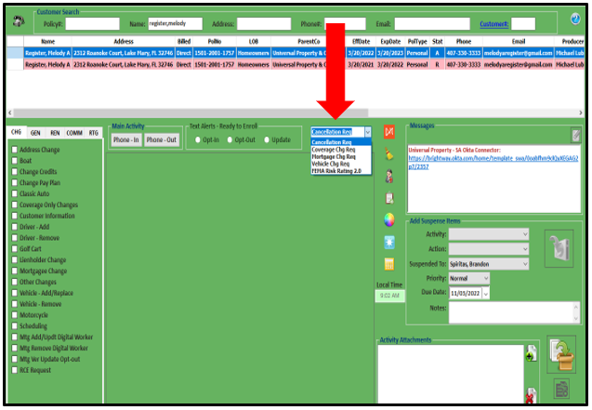

If the customer is making the payment for the policy and not the mortgage, make sure to cancel EFT (refer to pages 19-20) if they are on auto pay.

Go to the insurance company website and go to the billing section and verify who is making the payment, if it is the mortgage company, no extra steps are needed. If it is the customer, check to see if they are on EFT, if they are, make sure to cancel with the carrier.

Information Provided in the Email or by Phone

If the information to create the cancellation is included in the email that was sent or listed in the suspense request or advised via phone, complete the cancellation form.

1. Locate the Customer.
2. Highlight the policy to be cancelled.
3. Click eForms.
4. Click Cancellation

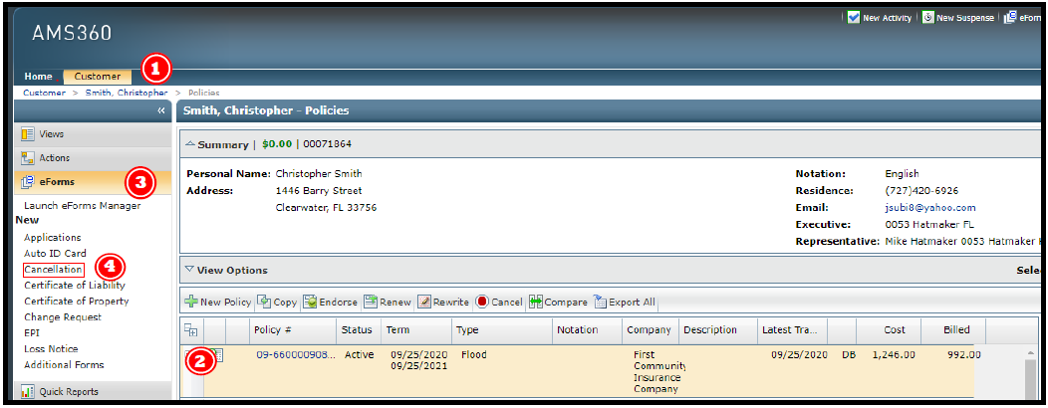

Enter the date on the ACORD Cancellation Request/Policy Release form.

1. Enter Cancellation Date
2. Enter Time (12:01AM)

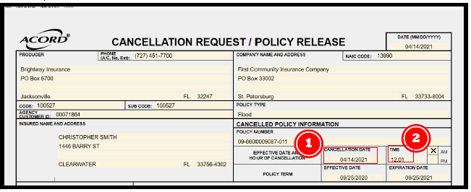

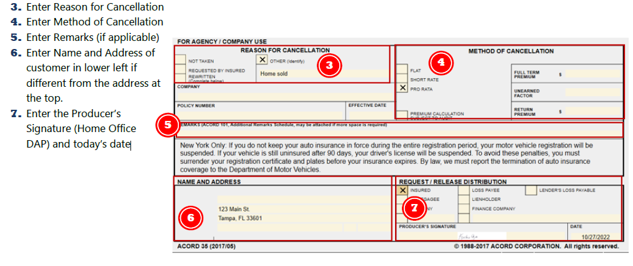

Once the form is completed, then we will send it out by either email or DocuSign. DocuSign is the preferred method as it will get the signature the fastest.

- Click on the Printer Icon at the top of the form to save the form.

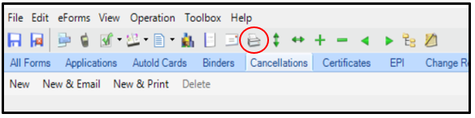

- Click on the Save as PDF button at the bottom of the box.

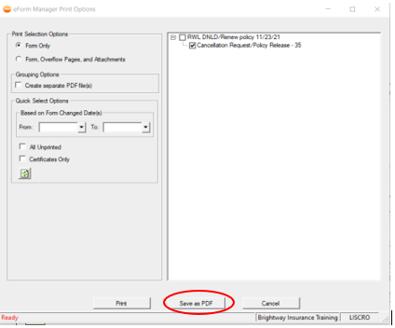

- Select the location of where you want to store the file along with labeling it Cancellation CUSTOMER LAST NAME Policy Number.

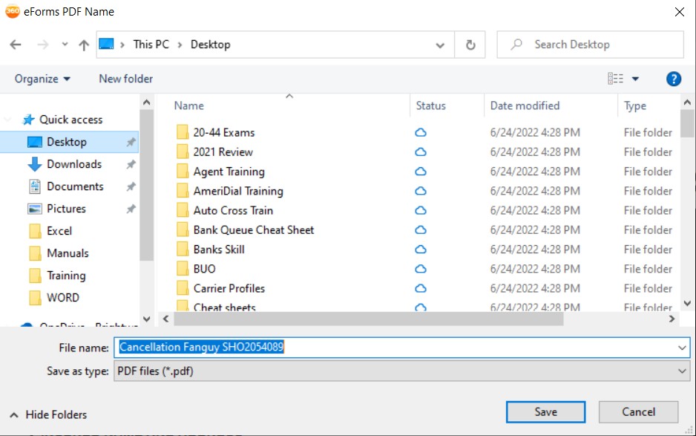
- An activity box will appear.
We will change the Action from Cancellation to Email (as we are emailing it through DocuSign) We will fill out the Email template from the Customer Service Activity Templates in the Description field after erasing the information in the field.

Email To: Customer Name via DocuSign
Email Address: Customer Email Address
Reason for Email: Canx due to (Sale of Home, Obtaining other Coverage)
CSR: YOUR ACRONYM

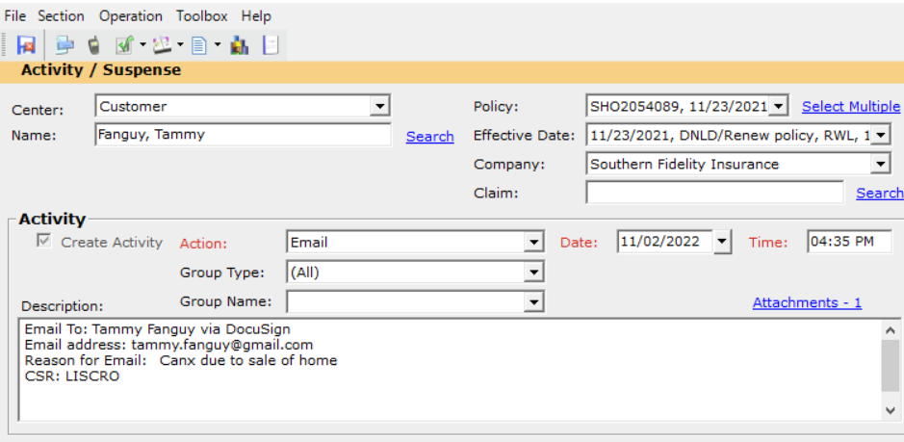

- Click on Attachments
Label the Attachment

Description: Unsigned Cancellation
Doc Type: Cancellation

Click ok after labeling

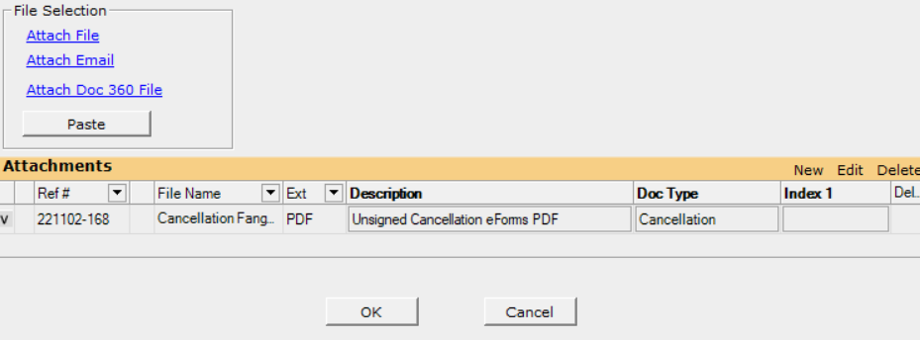
- Save and close the Activity box.
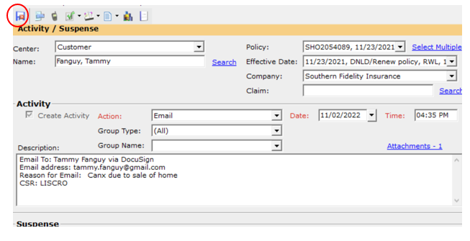

- Save and Close the Cancellation Form

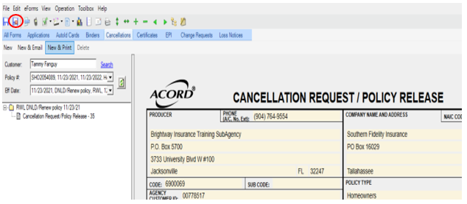

- Sign in to DocuSign

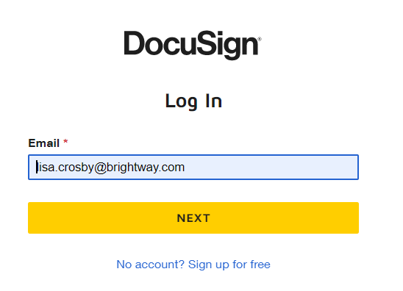
- Click on Start and then Use a Template.

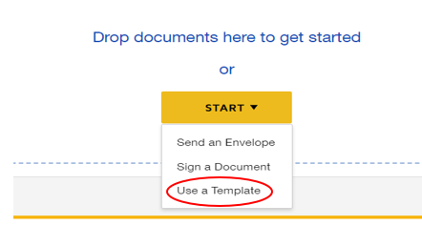

- Select the Automatic Reminders Template.

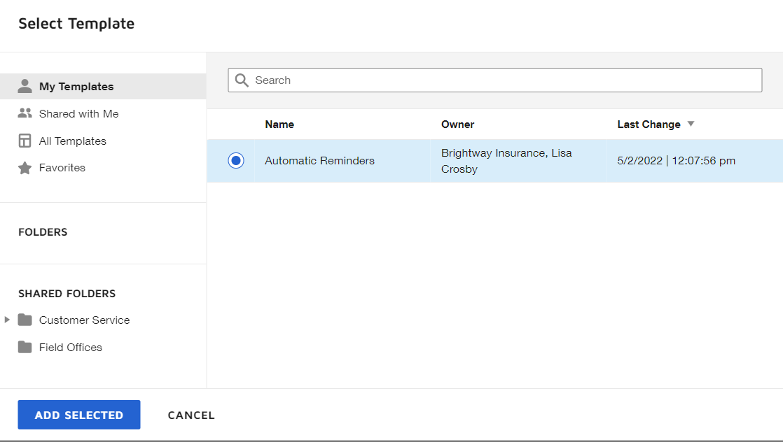

- Upload the cancellation form.

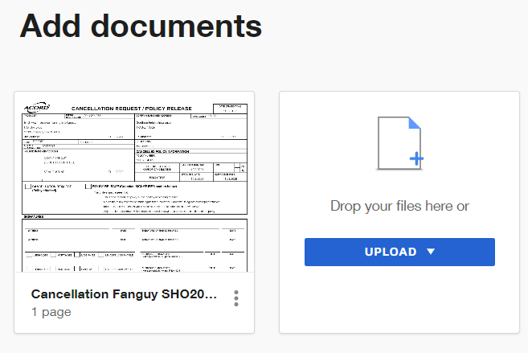
- Scroll down to Add recipients
Put in the customer’s first and last name and their email address

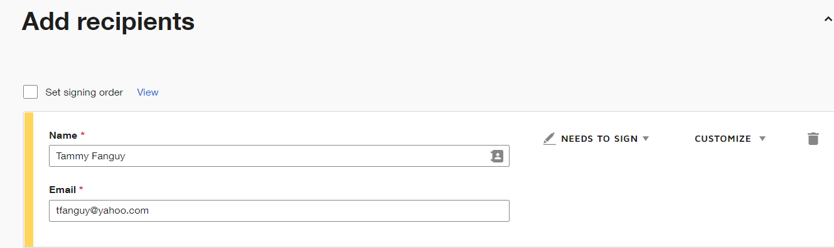

- Scroll down to the Add message section.

Remove .pdf from the subject line.
Type your message in the Email message portion.

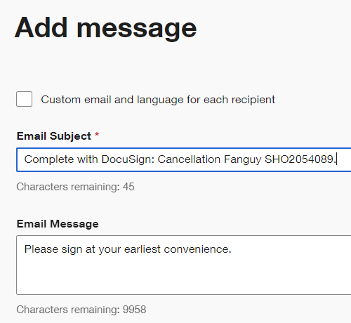

- Click on Next and then drag the signature and date to the lines and click send.

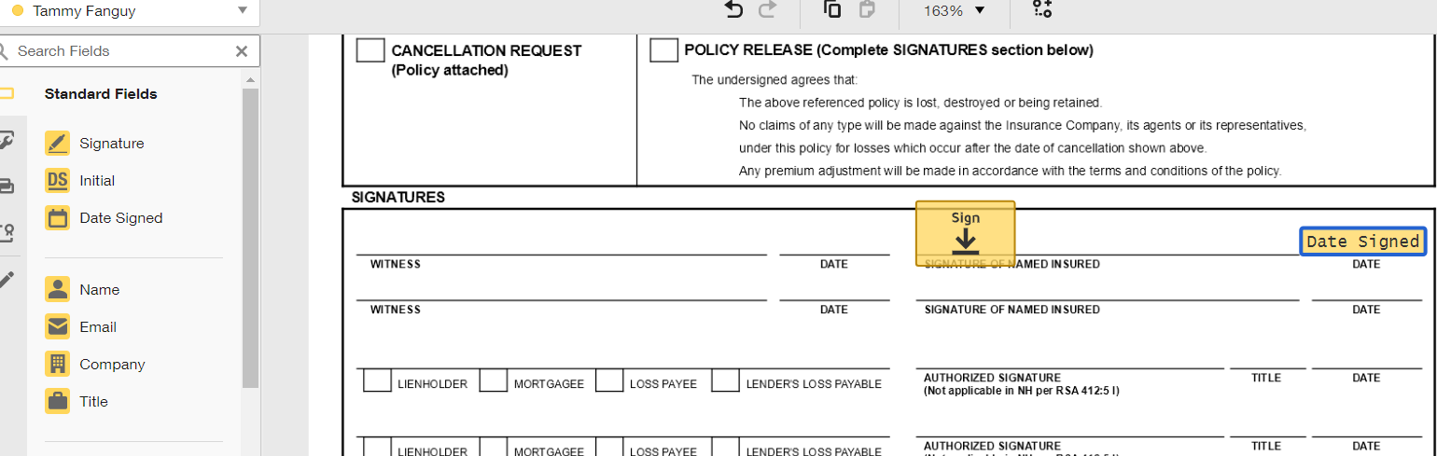
Once the form is completed fill out the GUI cancellation template.

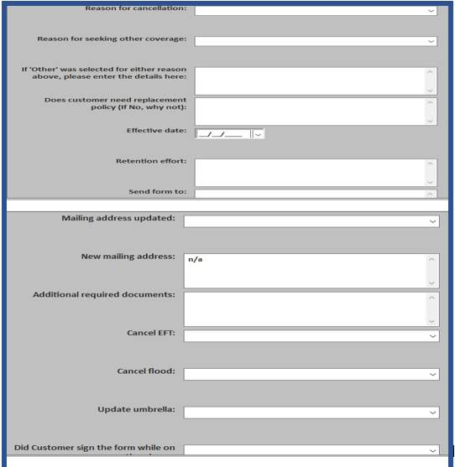

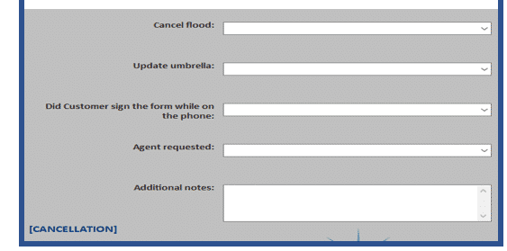
When you complete the Cancellation Template in GUI a suspense will be auto created when you select the option under "Did the customer sign the form on the phone". If you select yes, and supporting documents were received, a notice will go to the Agent of record. If you select yes, but no supporting documents were received, a notice will go to the agent and a 7 day follow up suspense for the supporting docs will be created. If you select no and no supporting docs were received, both the notice to the agent and the waiting on docs suspense will be created.

If you get the formed signed back with the supporting documents while you are working on the policy. Either upload or email to the carrier and complete the Cancellation Confirmation template in GUI.

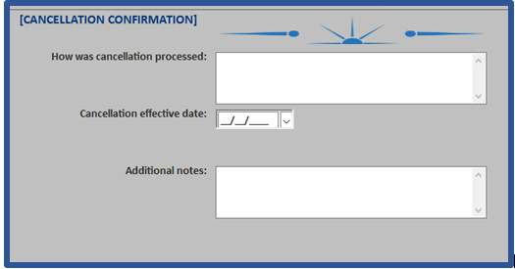

Someone from processing will check with the carrier and verify that the policy was cancelled as requested and will note and close the suspense.

*Make sure not to create any of your own cancellation suspenses as they are automatically created when you complete the GUI Templates.

If there are multiple suspenses open for the same item, close the duplicate suspenses.

Cancelling Electronic Funds Transfer

It is important when cancelling a policy to determine who is paying for the coverage. Most carrier sites list this information in the Billing or Accounting section.
Is it billed to the Mortgagee?
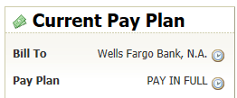
If it is billed to the mortgagee, you will not need to take any additional steps.

Is it billed to the Insured?
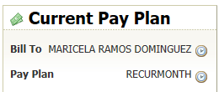

If it is insured billed, is it a Pay in Full plan or is it on an Installment plan?
- Pay in Full
  - If paid for the policy term
    - Check to see if set up for auto pay for next term
    - If on auto pay, cancel the auto pay

- Installment Plan
  - Payment
    - Auto Pay
      - If set up on Electronic Funds Transfer
        - Cancel Electronic Funds Transfer on the carrier’s site
        - If unable to cancel on carrier site, contact carrier to cancel.
    - Self Pay
      - Insured mails in payment or pays on-line
        - No action Needed

Sample for cancelling EFT
Cancelling EFT/Automatic Payments
To cancel electronic payments, EFT:
- Click on the Billing Tab

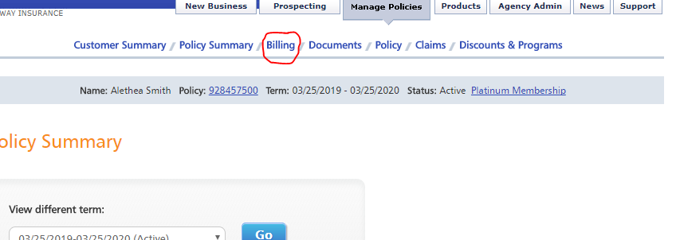

- Click on the Stop Automatic Payments on the left panel.

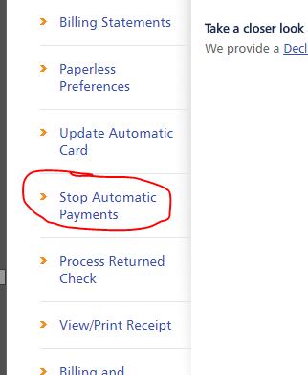

- If this option is not there, contact the carrier.

**Note auto pay is most common on auto policies**

When signed cancellation request and other required documentation are received
- Highlight the policy in Policy View
- Click New Activity on the quick access toolbar
- Action: Email
- Description: Use the “Email-Fax” template
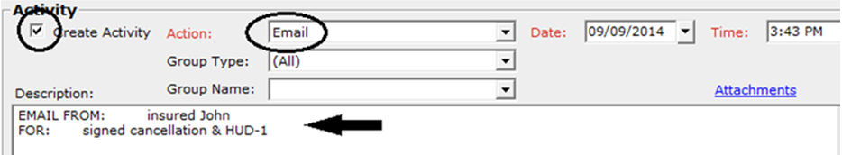
- Drag and drop entire email with the signed Cancellation Request and any other required documents onto the Activity window

- Enter Email Attachments Description: (indicate the sender and what was sent)
- Click Doc Type: Email
- Enter PDF Attachments Description: signed (carrier) cancellation
- Click Doc Type: Cancellation
- Properly label any other attachments
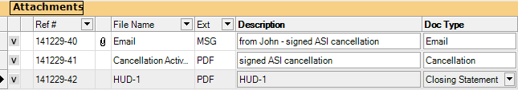
- Click OK
- Click Save & Close to exit the Activity / Suspense window
- Follow the preferred method of the carrier to cancel the policy per one of the following:
- Upload the signed cancellation form via the carrier website & create a new “Website” activity
- Email the signed form to the carrier from within AMS and update the “Email” activity
- Cancel the policy yourself on the carrier website and keep the signed cancellation form in AMS

Email System; Processing Cancellations

Within the Email System

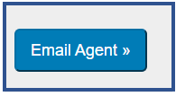
- Log in to the Email System.
- Click on Email Agent.
- Click on Ready.

- Change your state to Available.

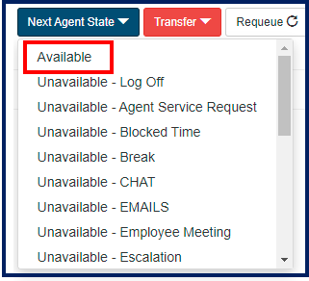

- The DocuSign will be attached in the email.
- Click on the Cancellation form attached to the email.

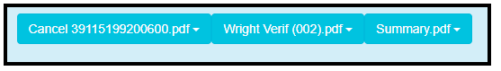
- Download the cancellation request form.
- Save to your computer to upload to the carrier site. Make sure to label with Form type, Customer’s Last Name, and their policy number.
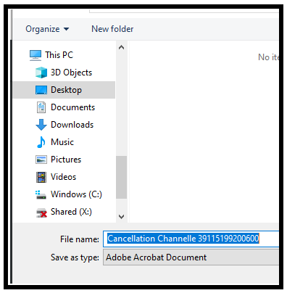

- Download and save any other attached documents that need to be uploaded to the carrier site along with the summary page.
- If no other documents are attached, determine if any supporting documents are needed.
  - Home Sold (Immediately for flood, backdating 30 days for Home)
    - Acceptable proof
      - Updated Warranty Deed
      - Closing Statement
      - HUD Form
  - Obtained other coverage (Backdating 30 days)
    - Declarations Page from new carrier showing inception date.
- If supporting documentation is needed, check in AMS for the documentation by locating the customer’s policy in AMS and looking under the documents tab.
- First locate customer in the email system by putting in Policy number, customer number, name, email, address, or phone.

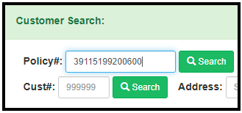
- Double click on the customer’s name or any of the boxes on the same line with the customer’s name to open in AMS.

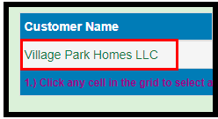
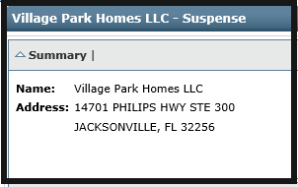

- Click on the Documents tab to check for any supporting documents if needed.

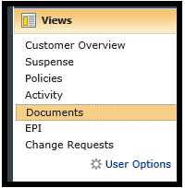

- If the document(s) are located, download, and save.
- If supporting documents are not there, email the customer requesting the supporting documentation.
- To email the customer, highlight Policies under views and highlight the corresponding policy.

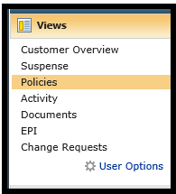



- Click on Contacts at the bottom of your AMS screen.

- When the email box pops up, the customer’s email address will be highlighted, click on To-> to have the address prefilled for you.

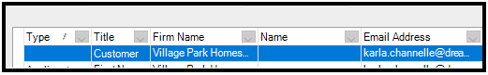

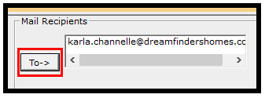

- Click on the blue word Email which is the hyperlink to open an email.

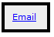

- Change the From to serviceteam@brightway.com.
- Use the Cancellation Need Info signature, update as needed.
- Note the email activity.
- If all documents have been received, upload the signed cancellation request and any supporting documents to the carrier site if able to upload to the carrier, if not email the carrier the documents.

NOTE
Not all carriers are aware when you upload documents to their site, send an email to advise it has been uploaded and to process, once you have uploaded; Check the QRG to verify if you can upload to the carrier’s website.

- Note that you uploaded the documents via AMS either through GUI or through AMS directly.
Within AMS
- Highlight Policies under Views and highlight the policy you are working on.

- Click on New Activity at the top of AMS.



- In the drop-down for Action, select Website.



- Use the template from the Customer Service Activity Template that says Doc Website Upload.



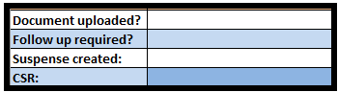

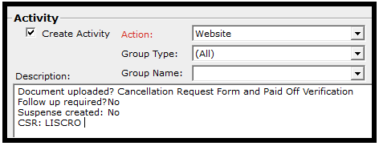

Within the GUI Template
- Locate the customer in GUI by putting in the Policy number, customer number, name, email, address, or phone.

- Highlight the policy and policy term you are working on.

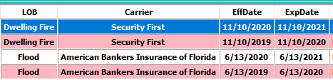

- Click on the General tab on the left-hand side of GUI and select Doc Upload/Website.
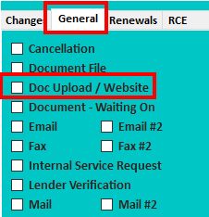

- Notate what was uploaded on the carrier site.

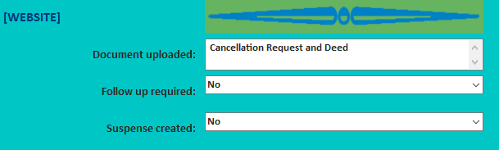

- Once you have noted, use the dark blue email button to drop the email with the signed documents into AMS.

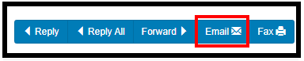

Cancelling a policy in AMS
- Once the carrier has cancelled the policy on their site and it does not show cancelled on ours, highlight the policy in Policy View (do not click directly on the Policy #)
- Click Cancel button on policy view toolbar
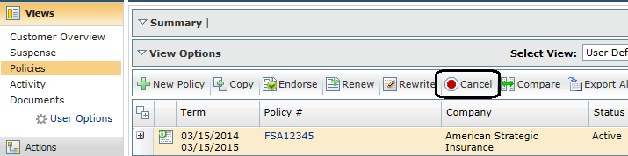
- A new window opens:
- Enter Transaction: Cancellation request
- Enter Effective Date
- Click Reason (use “Other” if specific reason is not listed)
- Enter Description (detail of reason for cancellation)
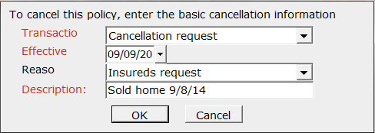
- Click OK
- Click No when prompted to update the expiration date:
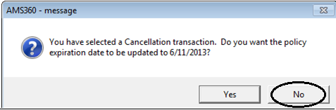

- Click Yes when prompted to set the Status to Cancelled:
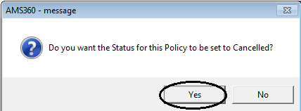
- Click Save & Close to exit the Policy
- Update the Activity:

- Action: Cancellation Request

- Description: defaults

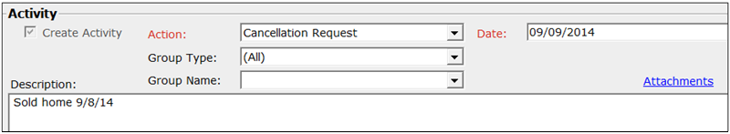

- Click Save & Close to exit the Activity / Suspense

Cancellation Suspenses

Determine the reason for cancellation and if the cancellation can be rescinded, if not stated specifically on the notice from underwriting, contact must be made to the carrier.
(Minimum of 2 attempts required)
If cancellation can be rescinded-
- Make an attempt then push suspense out for 3 business days
- Make 2nd attempt
  - If the customer commits to the requirement(s) needed to rescind the cancellation push the suspense 7 business days unless otherwise specified by customer
- If during any attempt the customer declines to complete the requirement(s) needed to rescind the cancellation, follow the below steps for a cancellation that cannot be rescinded.
- If unable to speak to the customer after the 2nd attempt or upon failure to rescind cancellation, follow the below steps for a cancellation that cannot be rescinded.
If cancellation cannot be rescinded-
- If four (4) weeks or more before cancellation date. Create a “Service Agent Notification” activity/suspense to the primary representative. Complete open processing suspense.
- If two-three (2-3) weeks before cancellation date. Send an email to the primary representative and create a “Service Agent Notification” activity/suspense to the primary representative. Complete open processing suspense.
- If zero-one (0-1) week before the cancellation date. Call the primary representative to advise of the impending cancellation and create a “Service Agent Notification” activity/suspense to primary representative marked as “Critical” priority. Complete open processing suspense.
If information to rescind cancellation is received from the client-
- Submit information to the carrier using the carriers preferred method of contact (upload, email, or fax). Push suspense out for 10 business days to verify the carrier has rescinded cancellation.
- If further information is required after underwriting review. Make the minimum number of attempts required on this process to the appropriate party.
  - If rescission is denied by the carrier during this process, follow the above steps for a cancellation that cannot be rescinded.
If the cancellation is rescinded-
- Contact the client via email to advise the policy is in good standing.
  - If no email is available on the customer file, a phone attempt should be completed. The suspense should then be notated and completed.

What is an Attempt?

An attempt is defined as:

  - A single phone call out to the cell phone number on file located in the cell phone number field.
    - If cell phone number field is not populated, a single phone call should be made from the residential number on file.
    - If neither the cell phone number of residential number is on file, use the next number listed. I.E. the business phone number or other phone number.
    - If voicemail is received on the single outbound call, a detailed message should be left using the VM Script outlined in this process then proceed to step two below.
    - If you are able to speak to the customer during the phone outbound attempt omit step two.
  - Send an email to the client
    - Follow the email scripting specific to the process for the suspense you are working.
    - If no scripting is available your email should outline specifically what is needed, when it is needed, and where to send the information.

VM Script –
Hi, I’m calling from Brightway Insurance regarding your TYPE Policy Number ###.

[INFO ABOUT WHY YOU’RE CALLING.]

Please contact our Service Center at 1-888-254-5014 between 8 a.m. and 7 p.m. (Eastern Time) Monday through Friday or on Saturday between 9 a.m. and 2 p.m.

Thank you for being a Brightway customer and have a great day

What if?
There is no valid phone number on file? I.E. Disconnected, ringing with no voicemail, or third party answers to indicate it is a wrong number
- Check the carrier website for alternate phone numbers and remove any incorrect phone number from AMS.
- Continue the attempt with sending an email.

There is no valid e-mail on file? I.E the email returned as unable to be delivered

- Check the carrier website for alternate e-mail addresses and remove any invalid e-mail address from AMS.
- Continue the attempt with a phone call to every phone number on file.

There is no valid phone number or e-mail on file?

- Check the carrier website for alternate phone numbers or e-mail addresses and remove any incorrect phone numbers or e-mail addresses from AMS.
- Mail a memo to the client’s mailing address, requesting updated contact information and include the scripting for the email in the memo. If no scripting is available your memo should outline specifically what is needed, when it is needed, and where to send the information.
- Create a “Service Agent Notification” Activity/Suspense notifying the agent that we do not have accurate contact information for the customer. Request the agent to send back the suspense to Personal Service with updated contact information, if available, to ensure the customer’s file is up to date.

Locating documents for cancellations

When you are backdating a cancellation that is more than 30 days for homeowners policies, we would need to send both a signed cancellation request and proof of sale (such as a copy of the settlement statement, warranty deed, or HUD stat00ement) or proof of other coverage at the same time. You can attempt to locate supporting documentation in AMS:
- To locate documents in AMS, select Documents under Views
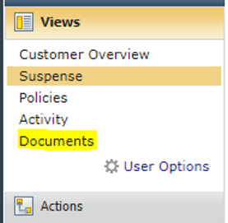
- Hit CTRL + F keys on your keyboard.
- A search box will appear.
- Type in “Cancellation.”
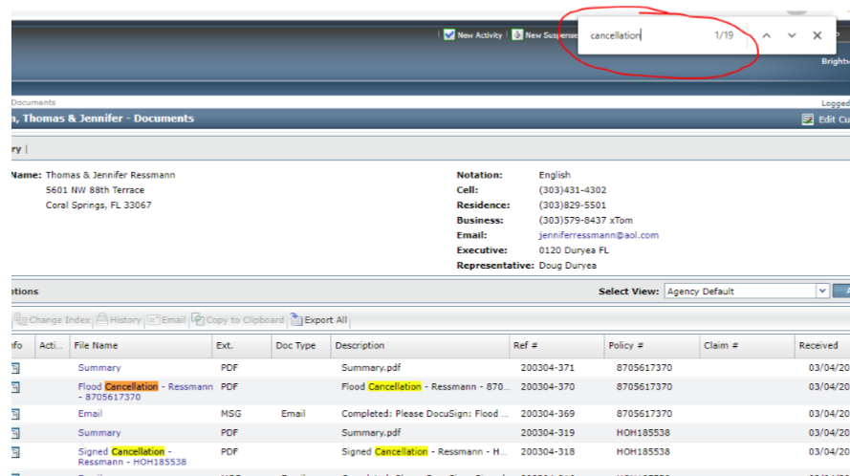

Outbound Mail Procedure

Any document(s) that needs to be mailed should be attached in AMS360 and a suspense routed to
Ginny Stevens to print and mail.

You must create a Form Letter (Docs to Customer) and save it in AMS for every item that needs to be mailed.

Attach the doc(s) to be mailed to any activity you have open and properly label the Attachment, create a
“Mail” Suspense from that Activity, but do not create a “Mail” Activity.

CSR Task

Creating the Form Letter:

- Click Views on the sidebar menu

- Click Policies on the sidebar menu – highlight the policy in policy view

- Click Actions on the sidebar menu

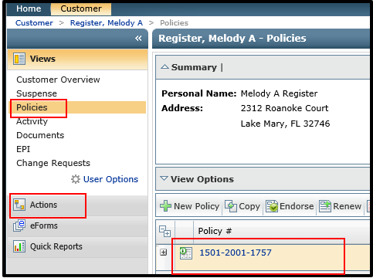

- Click Form Letters on the sidebar menu
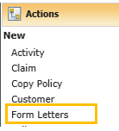

- .Category: Memos

- Document: Docs to Customer

- Make sure Policy # is correct

- Click View

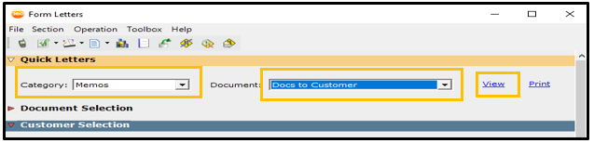

- List the documents that will be mailed

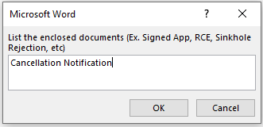

- Your cover letter will pop up in a Word Document.
- Delete the bottom portion of the letter with your personal information.
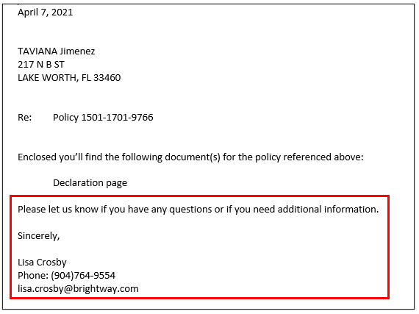

- Add the basic Brightway Information.
  - For further questions, please contact our Customer Service Center at (888) 254-5014. Our hours of operation are 8am to 7pm Monday Through Friday, EST and 9am to 2pm Saturday. Thank you so much for your business and for choosing Brightway.

Thank you and have a great day,

Brightway Insurance
P: 888-254-5014 | F: 866-776-8320
Processing@brightway.com
www.brightway.com
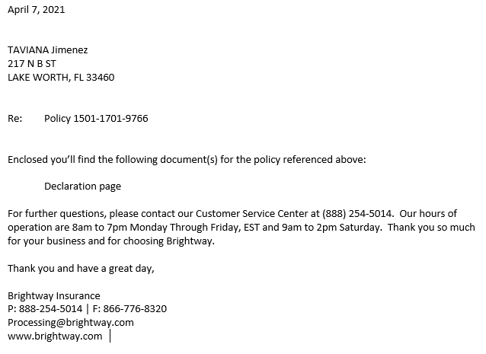

- Click on the save button at the top of the page to save the updated cover letter, do not print.

- Close the form letter by click on the x at the top right.

- Update the Activity
(Actions defaults to “Form Letter” do not change it)
  - Add the Mail Template in to the Description field.
  - Click on R Create Suspense
  - Change To: Stevens, Ginny
  - #Days: 0
  - Change Action: Mail

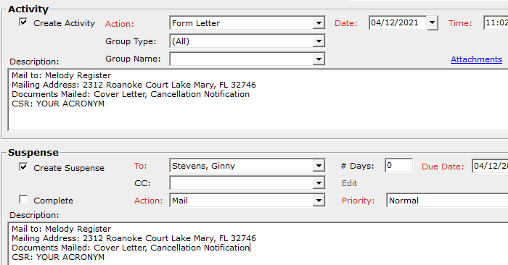
  - Click Attachments
  - Drag & drop or click on Attachments and search for the document to be mailed and add to the attachments.
  - Put Memo for the doc type for the Cover Letter.
  - Select the correct doc type for the other document.
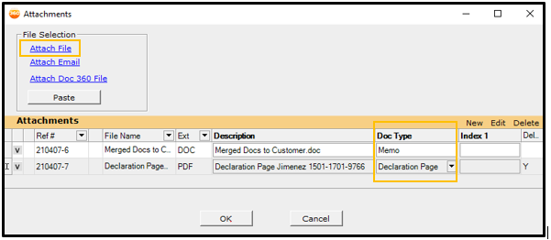

  - Click Save & Close to exit the Activity / Suspense

**If there is no cancellation notification to attach from the carrier, type message in the body of the cover letter to send out to the insured.**

Carrier Navigation Guides

Aegis
- For Aegis Insurance, click on the Search button.
- 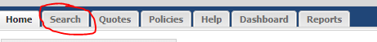
- Enter policy number.
- Click on the Search button.
- 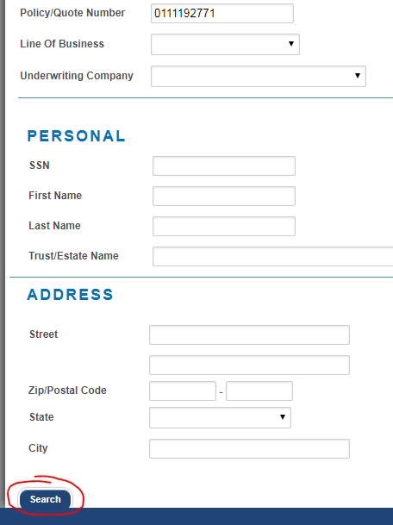
- Click on the policy number link.
- 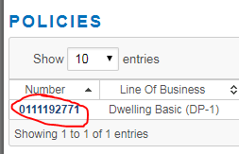
- Select the Documents tab.
- 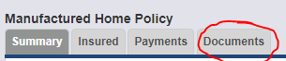
- Click on the Upload Documents button.
- 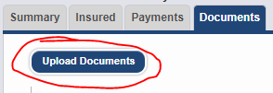
- In the description, enter brief description of the document.
- Click on the Attach Files button.
- 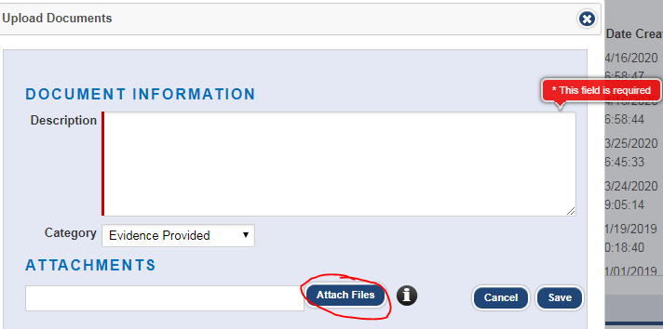
- Click on the Save button.
- 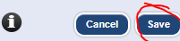

All Risks Limited
- For All Risks Insurance, click on the Get a QuickHome Quote button.
- 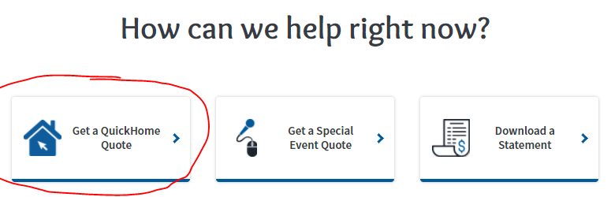
- Click on the Quote Now button.
- 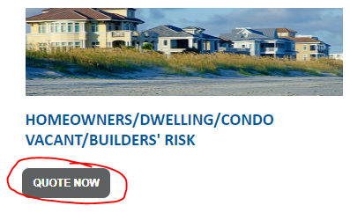
- In the Find drop-down menu, select By Policy.
- 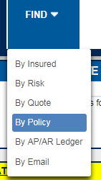
- Enter policy number.
- 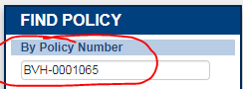
- Click the Search button
- 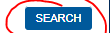
- Select the desired term.
- 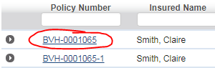
- Click on the Attach Files button.
- 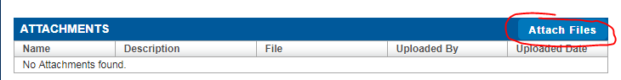
- Enter all required fields.
- Click on the Browse button.
- Click on the Save Attachments button.
- 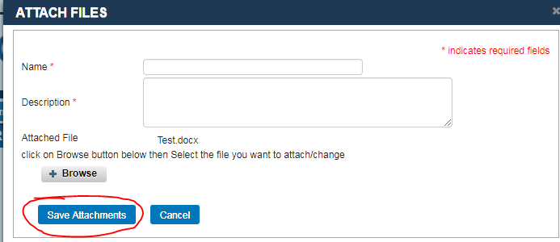

Allied/Nationwide
- On the main screen for Allied/Nationwide, first click on the drop down for the Search Type box.
- Select Policy – Personal in the drop-down menu.
- Enter in the policy number in the Policy Number box.
- Then click the Search button.
- 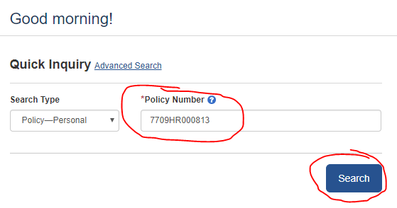
- Click on the Document Vault link under tools on the left side panel.
- 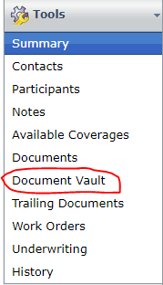
- Click on the Upload a Document button.
- 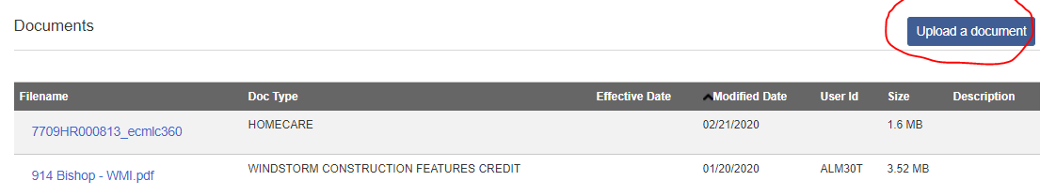
- Click on the Browse button and select the document that is to be uploaded.
- For DocuSign documents, you would select the eSignature Document box.
- In the Doc Type drop-down menu, select the appropriate document type.
- Click on the Save Document button.
- 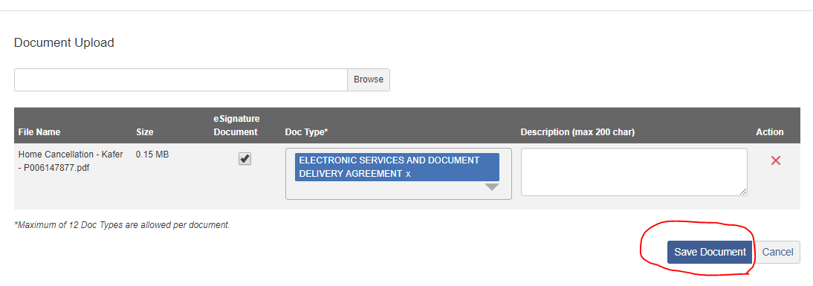

Auto Cancellation Process
- Once cancellation has been signed and sent back to us for this carrier, click on the Actions button.
- 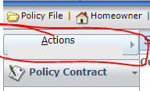
- Select Cancel Policy.
- 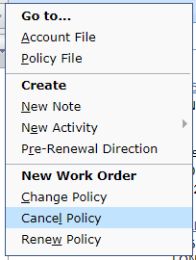
- In the Source drop-down, select Insured.
- In the Reason drop down, select the appropriate reason for cancellation.
- In the Reason Description box, type a brief description for the reason for cancellation.
- Enter the Cancellation Effective Date for the cancellation date requested.
- 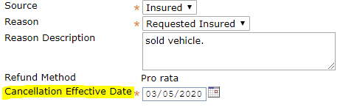
- In the Cancel Options drop-down, select either Cancel Now or Schedule Cancellation if it is to be cancelled at an earlier or later date.
- 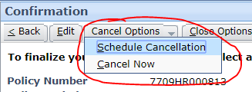

American Bankers Insurance of Florida
- For American Bankers policies, you will have to login to the National Flood Services site using the New Hampshire/American Bankers login credentials.
- 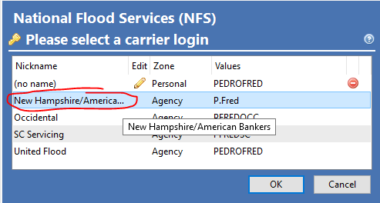
- You may be prompted with this Change Password window.
- Select No.
- 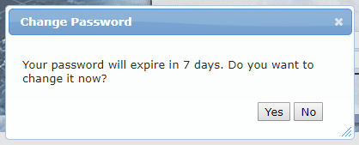
- This prompt will pop up, just click on the Skip button.
- 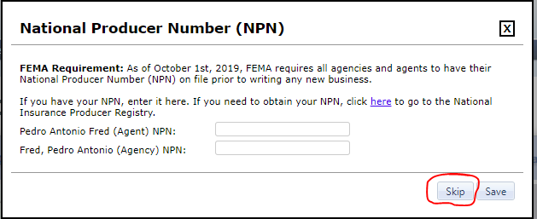
- In the Quick Search box on the top right, enter in the policy number.
- Click on the magnify glass icon.
- 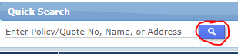
- Click on the Documents icon.
- 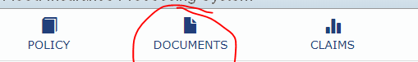
- Select Upload Documents.
- 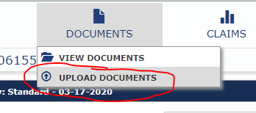
- In the “What is this document related to?” drop-down menu, select the appropriate document type.
- For cancellations relating to the property being sold, select Cancellation.
- The Reason for Upload section will appear.
- In this drop-down menu, select Building Sold or Removed.
- In the Message, type in “Please process this request.”
- Click on the Select icon.
- 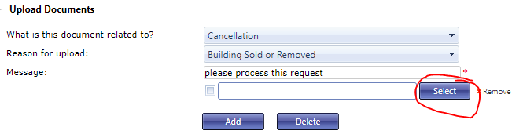
- Select the appropriate document.
- Click on the Open button.
- 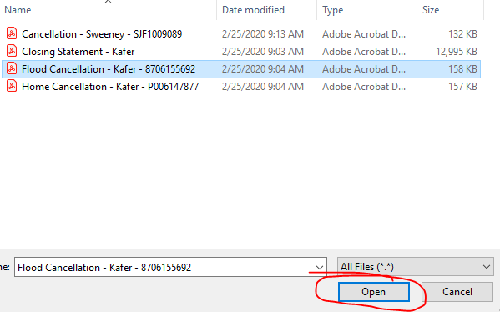
- To add another document, click on the Add button.
- Click on the Submit button.
- 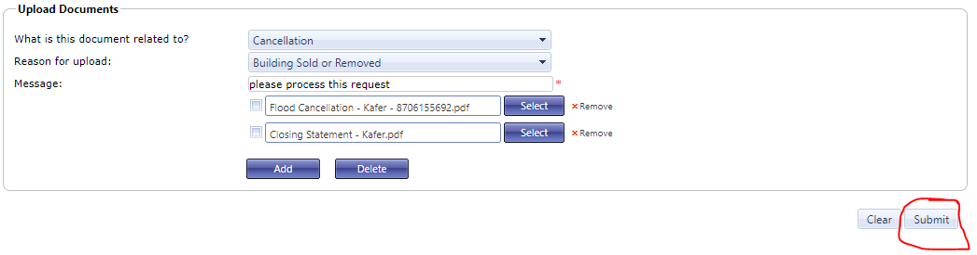

American Colonial Insurance
- For American Colonial, please refer to the Email from AMS section of this SOP as you cannot upload documents to their website.
- The email address to send to this carrier is personallines@coniferinsurance.com.

American Integrity Insurance
- Enter in the policy number in the Search box.
- Click on the Search button.
- 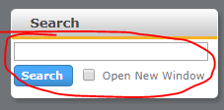
- Click on the Attachments tab.
- 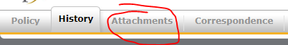
- Click on the Add Attachment under the Actions panel.
- 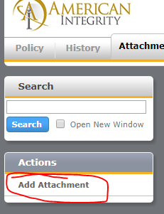
- In the Name drop-down menu, select the appropriate document type.
- Click on the Select button.
- Click on the Add Files button.
- 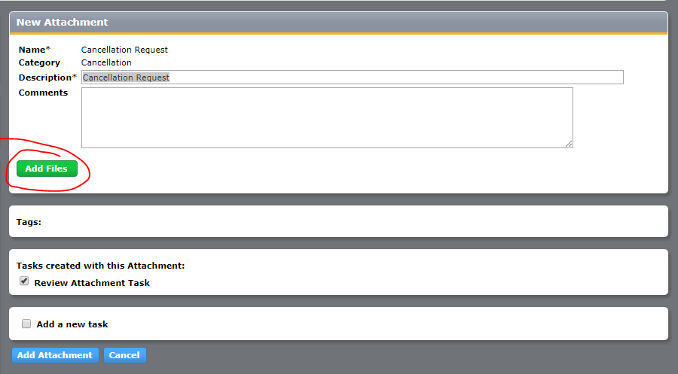
- Select the correct document and click on the Open button.
- 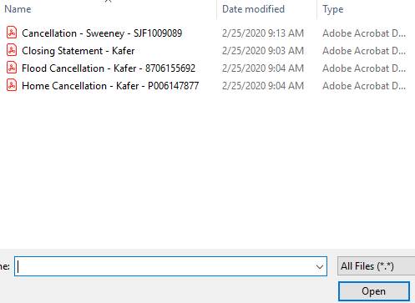
- Click on the Add Attachment button on the bottom.
- 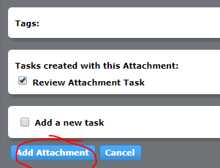

American Strategic Insurance (ASI)
- For American Strategic, please refer to the Email from AMS section of this SOP as you cannot upload documents to their website.
- The email address to send to this carrier is endorsements@americanstrategic.com.

American Summit Insurance
- For American Summit Insurance, please refer to the American Integrity Insurance section of this SOP.

American Traditions Insurance Company
- For American Traditions, if a policy starts with ATH you will have to login to the Homeowners portal and if a policy starts with ATM you will have to login to the Mobile Home portal.
- 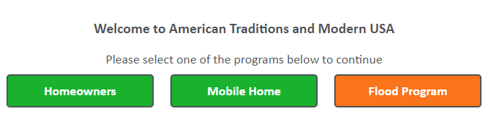
- Click on the Policy Administration button.
- 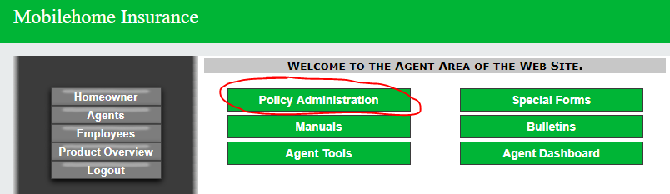
- Enter in the policy number in the Policy # or Last Name box.
- Click on the Quote/Policy Search button.
- 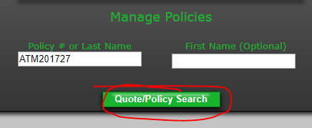
- Select the correct term by clicking on the policy number under the Policy ID section.
- 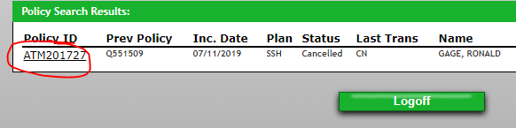
- Click on the icon with three lines.
- Select Document Upload.
- 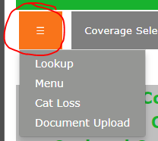

- Click on the Choose Files button on the correct document type.
- Once you have selected the correct document, click on the Upload Files button.
- 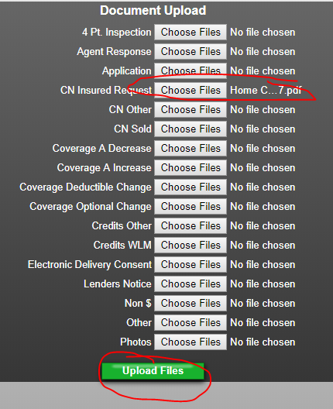

American Traditions Flood
- For American Traditions Flood Insurance, please refer to the Bankers Flood section of this SOP.

Americas Insurance
- For Americas Insurance, please refer to the Prepared section of this SOP for both the uploading documents and phone payments process.

Anchor Homeowners – LA Premier
- For Anchor – LA Premier, please refer to the American Integrity Homeowner section of this SOP.

Anchor Homeowners – TX Premier
- For Anchor – TX Premier, please refer to the American Integrity Homeowner section of this SOP.

Anchor Homeowners – TX Silver
- For Anchor – TX Silver, please refer to the Email from AMS section of this SOP as you cannot upload documents to their website.
- The email address to send to this carrier is txcustomerservice@relyonanchor.com.

Anchor Insurance
- For Anchor, click on the Search link on the left side.
- 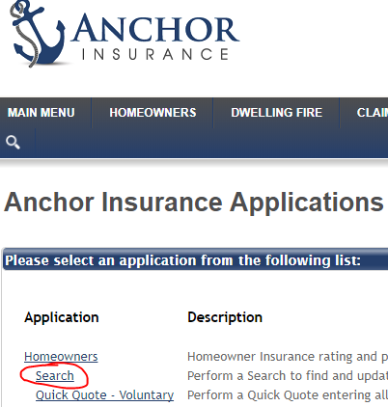
- Enter policy number in the Policy Number box.
- Click on the Search button. (NOTE: Be sure to hyphenate after the letters in the policy number and before the last two numbers.)
- 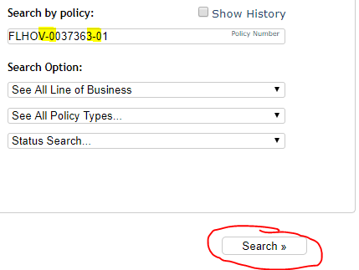
- Click on the Imaging button.
- 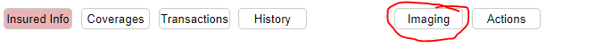
- Click on the Add Attachment button.
- 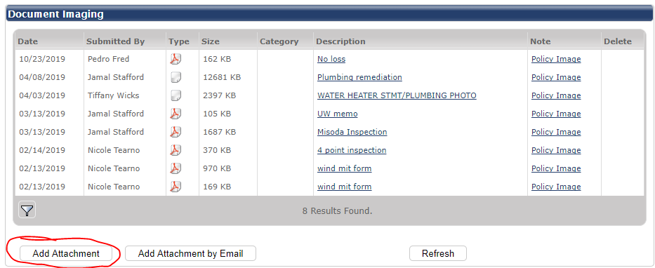
- In the description, type in “Please process this request.”
- 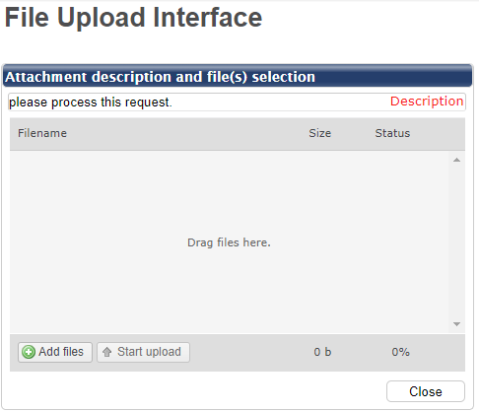
- Click on the Add Files button.
- Click on the Start Upload button.

- 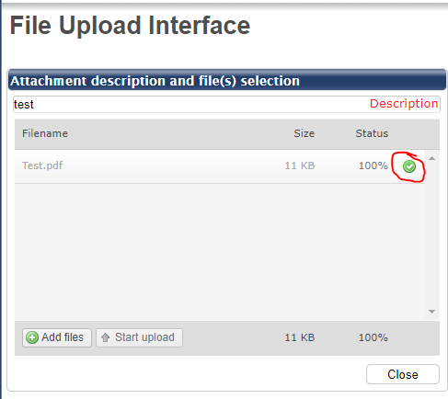

Assurant Flood/Sunshine
- For Assurant Flood, please refer to the American Bankers Flood section of this SOP.

Avatar Property and Casualty
- For Avatar, click on the Policy tab.
- 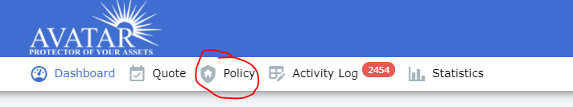
- Enter in the policy number in the Policy No. box.
- Click on the Search button.
- 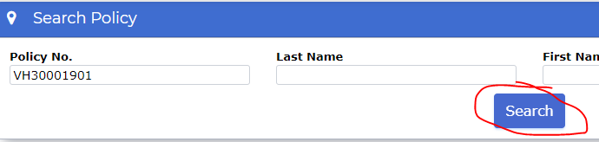
- Click on the policy number link under the Policy No. section.
- 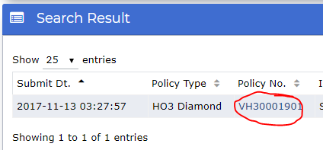
- Click on the Log icon.
- 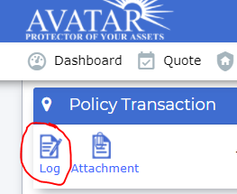
- Click on the Add New button.
- 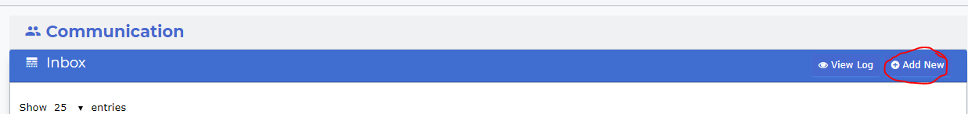
- Click on the Change Recipient button.
- 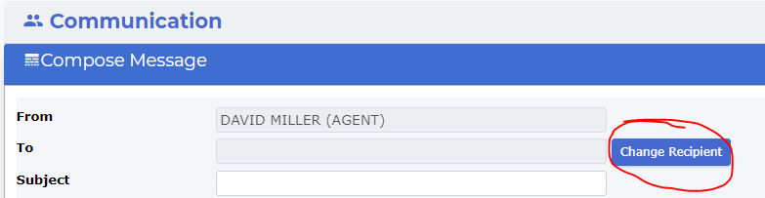
- Select the underwriter Anamaria Jaramillo.
- The reason for this is because that is the underwriter listed on the main screen shown below.
- 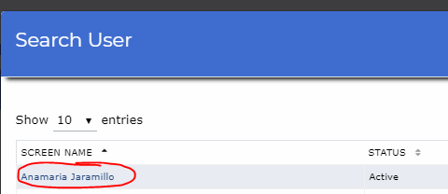
- Type in the Subject box the document reason.
- 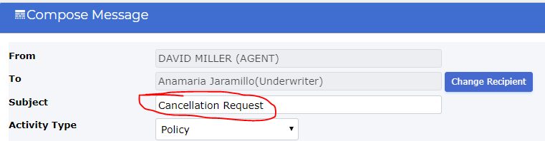
- For cancellations, make sure to put in the cancellation effective date in the Scheduled Date box.
- In the Document Type section, select Others.
- 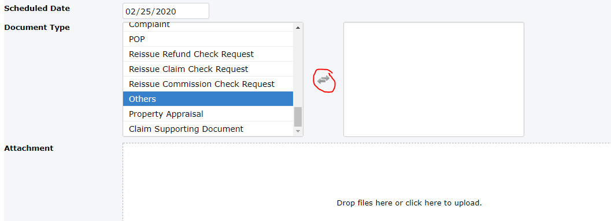
- Click anywhere on the Attachment box.
- In the text box, type in “Please process this request.”
- Click on the Save Activity button.
- 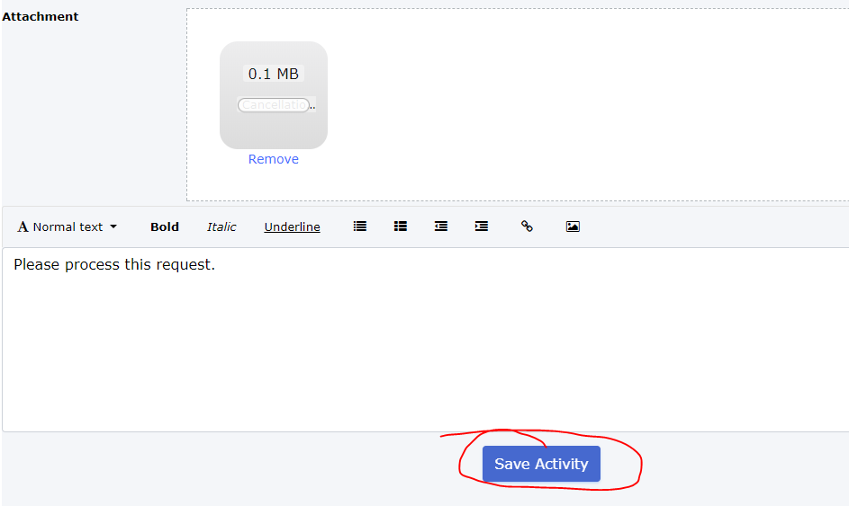
- Click the OK button.
- 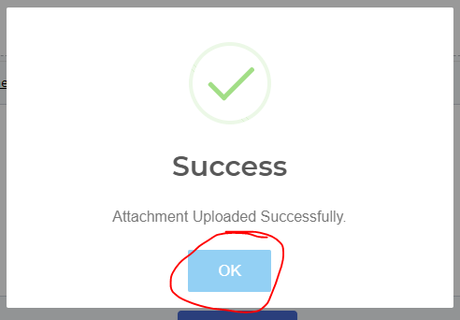

Bankers Insurance Company
- For Bankers homeowners’ policies, hover over Policy Processing and select Policy Search in the drop-down menu.
- 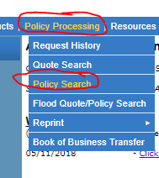
- Enter in the policy number in the Policy Number box.
- Click the Next button.
- 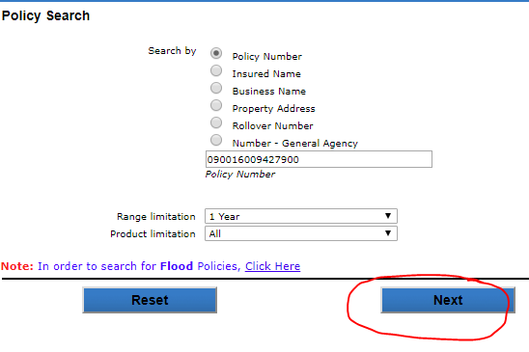
- Click on the paper with a pencil icon.
- 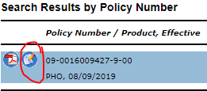
- Click on Submit Request/File Upload on the right side of the screen.
- 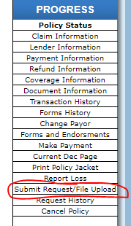
- In the Request Type drop-down menu, select the appropriate type of request.
- For cancellations, select Cancellations.
- Enter in cancellation effective date and in the request, instructions type in “Please process this request.”
- In the Pay/Refund to Name and Address box and Mail to Name and Address, enter in the insured’s name and new mailing address listed on the bottom of the cancellation request if there is a new address listed.

- 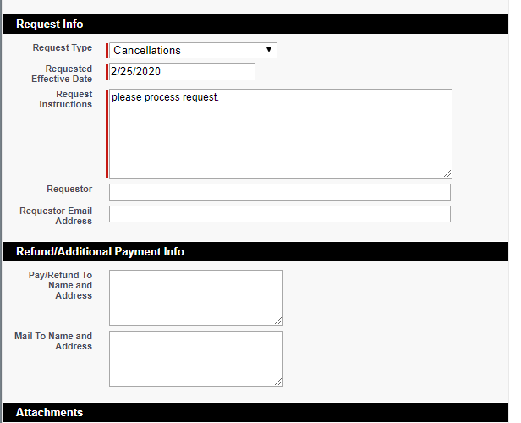
- Click on the Add New Attachment button.
- 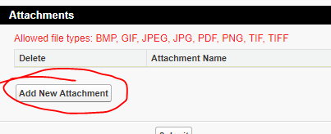
- Click on the Choose File button.
- 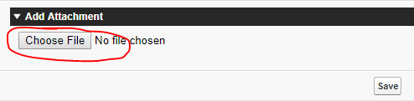
- Change the document type to All Files in the drop-down menu.
- Select the correct document and click on the Open button.
- 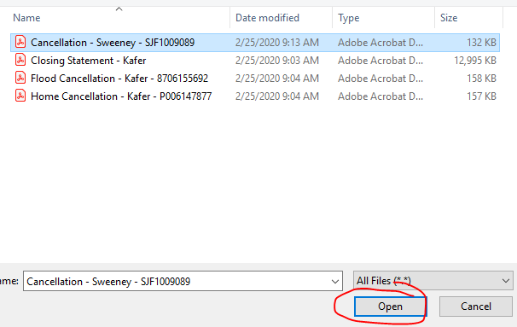
- Click on the Save button.
- 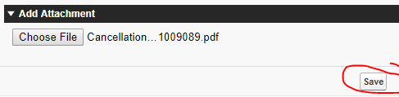
- Click on the Done button.
- 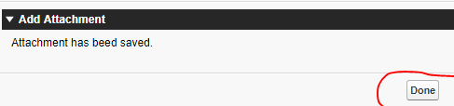
- Click on the Submit button.
- 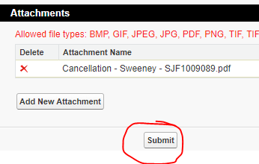

Bankers Flood
- For Bankers flood policies, hover over Policy Processing and select Flood Quote/Policy Search in the drop-down menu.
- 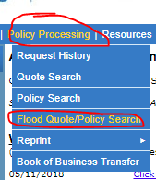
- Enter in the policy number in the Search box.
- Click on the magnify glass icon.
- 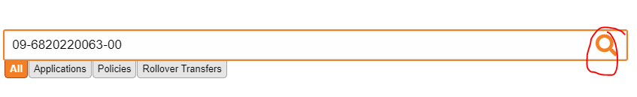
- On the desired term, under the Action section select View in the drop-down menu.
- 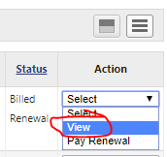
- Click on the Upload Document button on the right side under Documents.
- 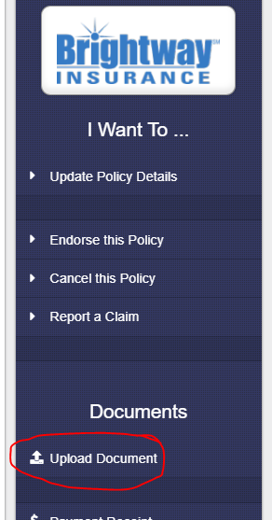
- Click on the Select Files button and select the correct document.

- In the Document Type drop-down menu, select the appropriate document type.
- Click on the Upload button.
- 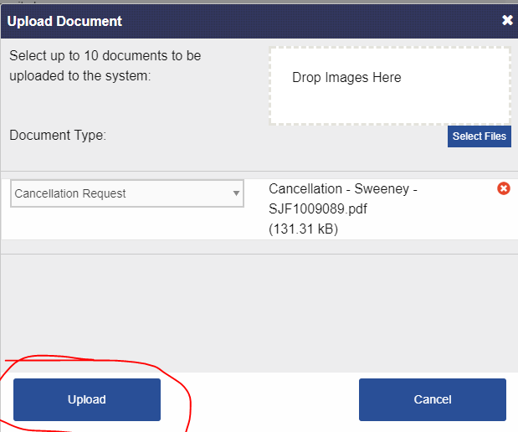

Bristol West Insurance
- For Bristol West Insurance, hover over Manage My Customers.
- 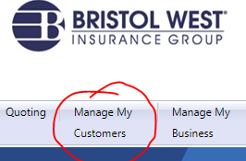
- Hover over Policy Search.
- Select Search by Policy.
- 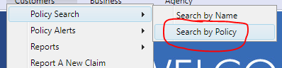
- Enter the policy number in manually.
- Click on the Search button.
- 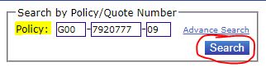
- In the Options drop down, select Submit a Document.
- 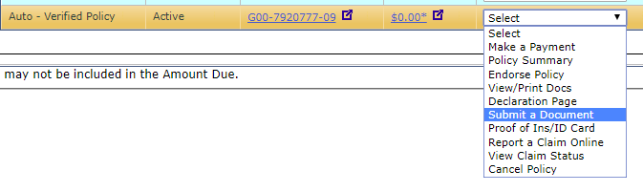
- In the drop-down menu, select the correct type of document.
- 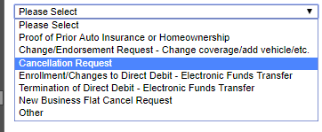
- Click on the Choose File button.
- 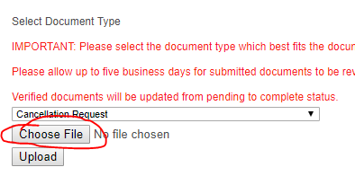
- Select the correct document.
- Click on the Open button.
- 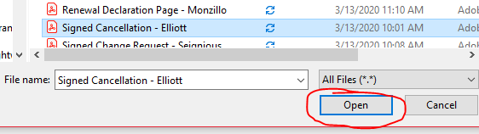
- Click on the Upload button.
- 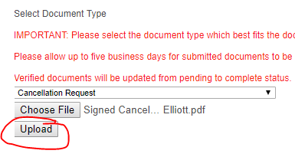

California Fair Plan Homeowner
- For California Fair Plan Insurance, please refer to the Email from AMS section of this SOP as you cannot upload documents to their website.
- The email address to send to this carrier is cfpuw@cfpnet.com.

Capitol Preferred Insurance Company*, Cypress Property & Casualty*, Edison Insurance Company*, United Property & Casualty*, Southern Fidelity Insurance*
- For Capitol Preferred, Cypress Property and Casualty, United Property and Casualty, and Southern Fidelity Insurance, please refer to the Email from AMS section of this SOP as you cannot upload documents to their website.
- The email address to send to Capitol Preferred is csr@capitol-preferred.com.
- The email address to send to Cypress Property and Casualty is policyinfo@cypressig.com.
- The email address to send to United Property and Casualty is upc@dxc.com.
- The email address to send to Southern Fidelity is csr@southernfidelityins.com.
- For Edison Insurance, click on the QuIS system link on the top of the screen.
- NOTE
- For all renewal terms with this carrier and Florida Peninsula, they have now transitioned to the Duck Creek system. Please refer to the Edison homeowners Duck Creek System section of this SOP.

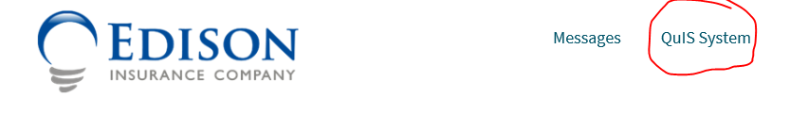
- Click on the paper icon. This will take you to the policy search screen.
- 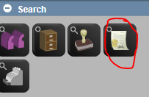
- In the middle Policy Number box, enter only the middle 7 numbers of the policy number.
- Click on the Search button.
- 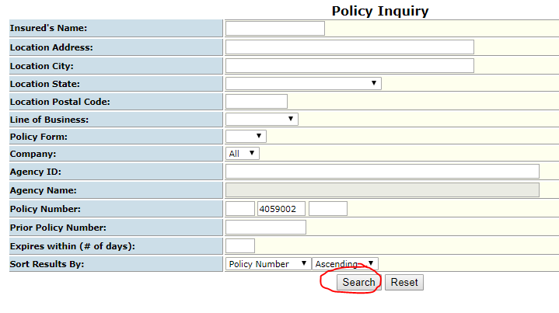
- Select the desired term by clicking on the policy number link under the Policy Number section.
- 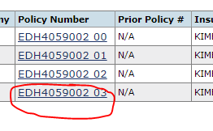
- Click on the Policy Documents tab above.
- 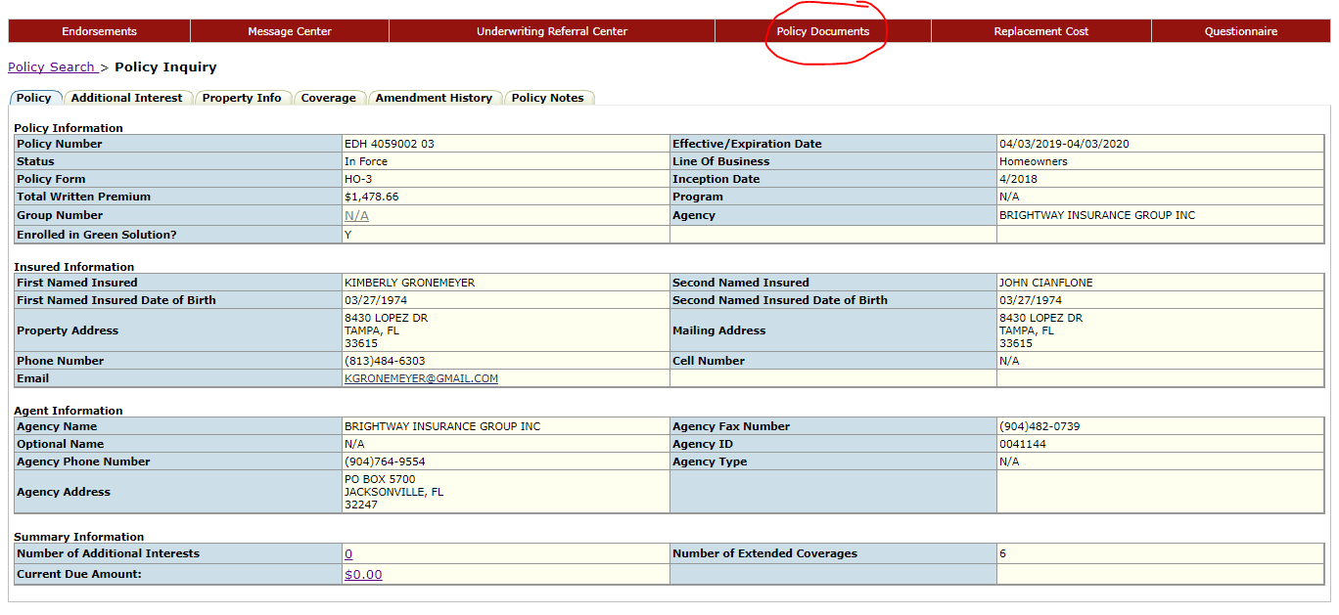
- Click on the New Attach tab.
- Select the correct document type in the Document Type drop-down menu.
- 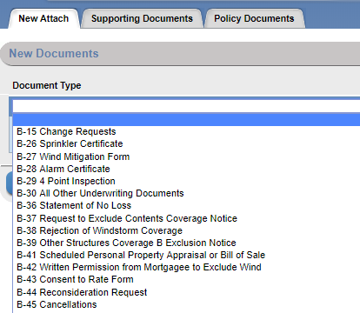
- Click on the Choose File button.
- 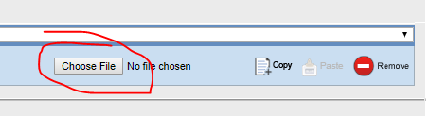
- Click on the Attach All button once document has been selected.
- 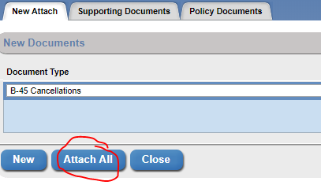

Citizens Property Insurance Company
- For Citizens Insurance, click on the Policy drop-down menu.
- Enter in the policy number in the Policy # box.
- Click on the magnify glass icon.
- 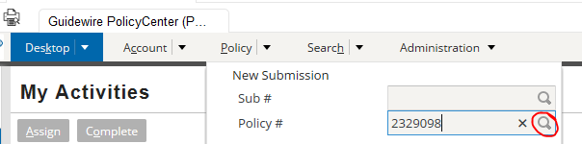
- For cancellations, click on the Actions button on the left side.
- In the drop-down menu, select Cancel Policy.
- 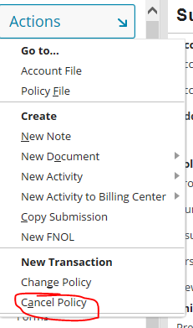
- In the Reasons drop-down menu, select the correct reason.
  - For example, if the insured sold the home it would be Insured Request – The property was sold (C072)
- If the mailing address is different, select the Yes bubble to enter in the new mailing address.
- Enter the new mailing address in the New Mailing Address box.
- Set the Cancellation Effective Date for the cancellation effective date on the cancellation request.
- Select the A completed and signed ACORD Lost Policy Release Form box.
- Click on the Start Cancellation button.
- 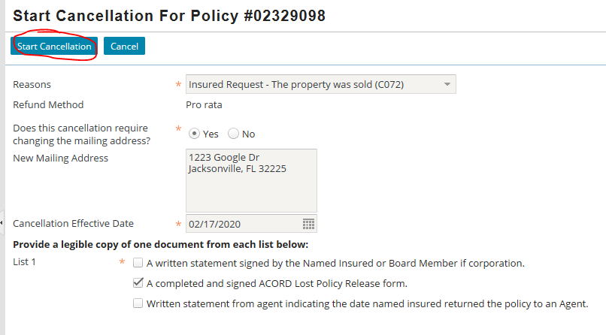
- Click on the Upload button that is now available.
- 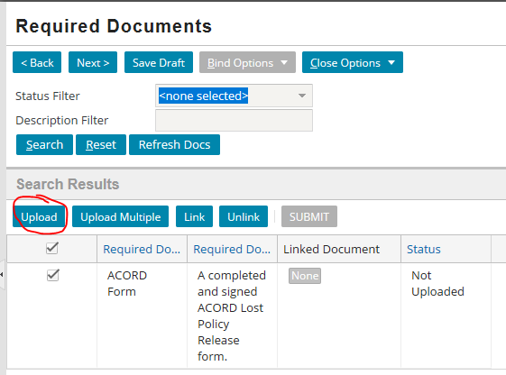
- Click on the Browse button and select the correct document.
- Click the OK button.
- 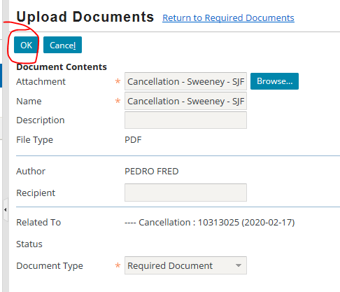
- Click on the Submit button.
- For any other documents to upload, click on the Actions button on the left side.
- Hover over New Document.
- Click on Upload documents.
- 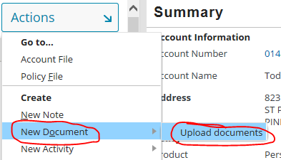
- The Workspace should populate.
  - It may be hidden like this:
- 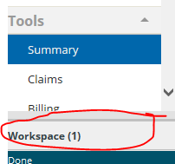
- If this happens, click on the up arrow in the bottom middle of the screen.
- 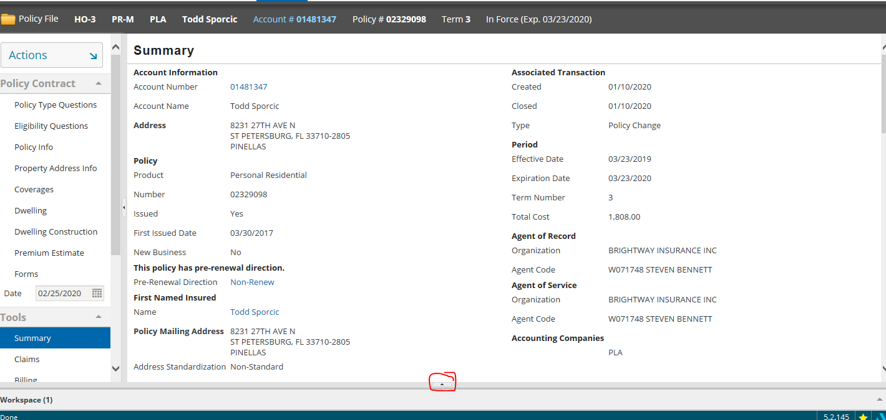
- Click on the Add Files button.
- 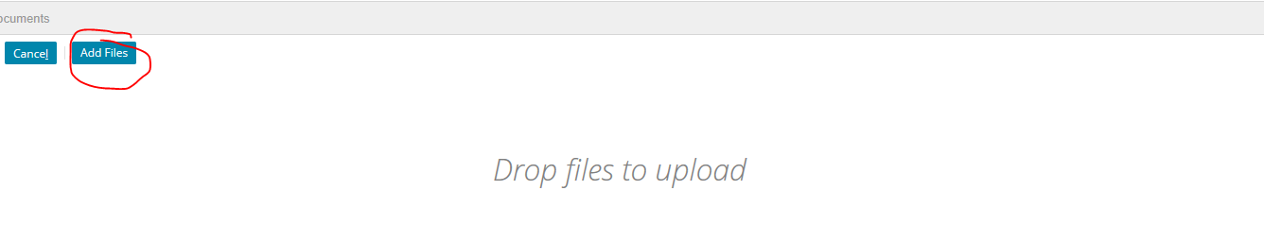
- Enter all the information required.
- Click on the Upload button.
- 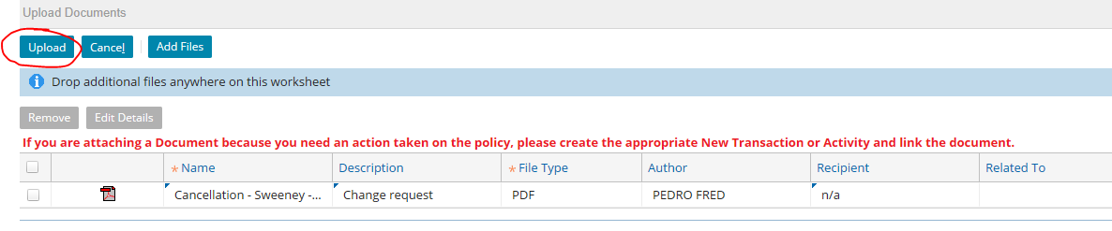

Dairyland Insurance
- For Dairyland, please refer to the Email from AMS section of this SOP as you cannot upload documents to their website.
- The email address to send to this carrier is dairylandauto@sentry.com.

Edison Homeowners *Duck Creek System*
- For Edison Insurance Duck Creek, please refer to the Email from AMS section of this SOP as you cannot upload documents to their website.
- The email address to send to this carrier is customerservice@edisoninsurance.com.

Encompass Insurance
- For Encompass Insurance, enter in the policy number.
  - NOTE: You must remove the letters from the policy number to locate the policy.
- Click on the Search button.
- 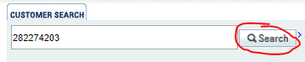
- Click on the policy number link.
- 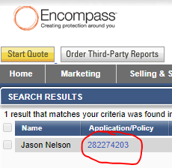
- Click on the Forms tab.
- 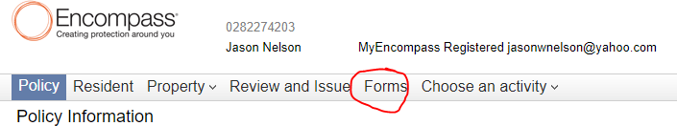
- Select the appropriate document to upload.
- Click on the Upload a File link.
- 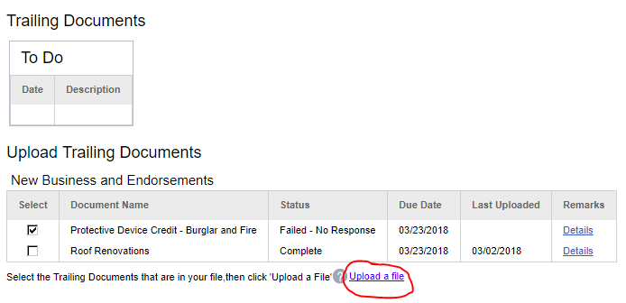
- Select the correct document.
- Click on the Open button.
- 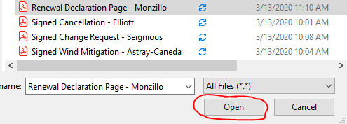

Excalibur Homeowners
- For Excalibur Insurance, please refer to the American Traditions section of this SOP.

Federated National Insurance
- For Federated National, click on the Point of Sale button.
- Click on the Homeowners / PTS button under Personal Lines.
- 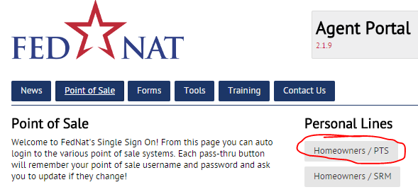
- Click on the Lookup Policy link.
- 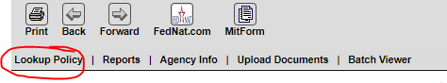
- Enter in the policy number in the Search Criteria box.
- Click on the Search button.
- 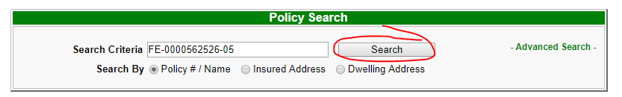
- Click on the policy number link under the Policy # section.
- 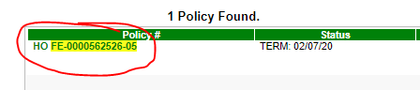
- Click on the Notes/Docs link.
- 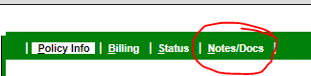
- Click on the Add link in the Attachments section.
- 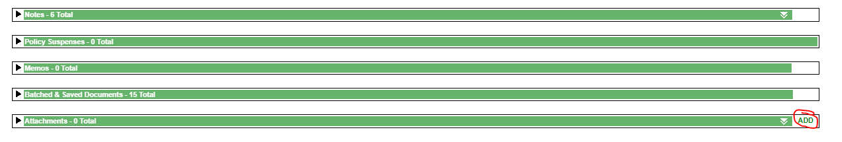
- Click on the Browse button.
- Enter a short description of the document.
- Select the document type in the Document Type drop-down menu.
- Type in “Please process this request” in the Notes box.
- Click on the Upload button.
- 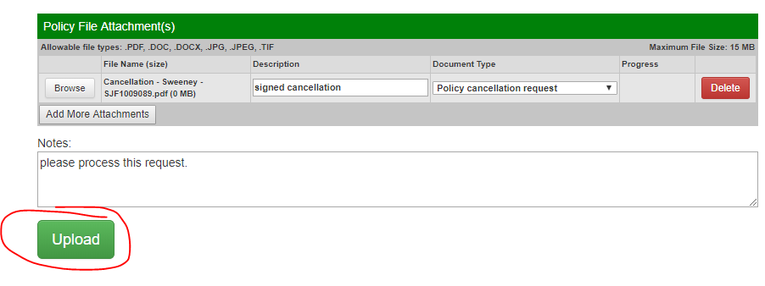

Florida Family Insurance
- For Florida Family Homeowner, click on the View a Policy button.
- 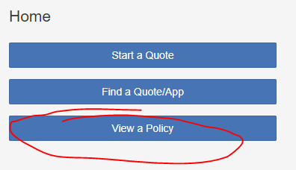
- Enter in the policy number in the search box.
- Click on the magnify glass.
- 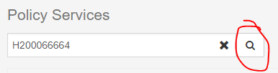
- Click on the policy number link under the Policy # section.
- 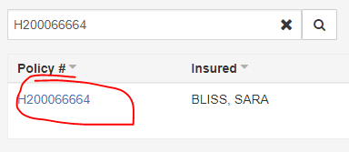
- Click on the Documents tab.
- 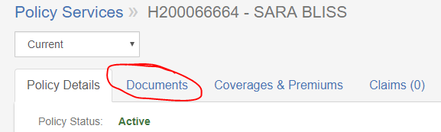
- Scroll down to bottom of the screen.
- Click on the or browse for a file link in the Upload Documents box.
- In the Description drop-down menu, select the appropriate document type.
- Click on the Complete Upload button on the bottom right.
- 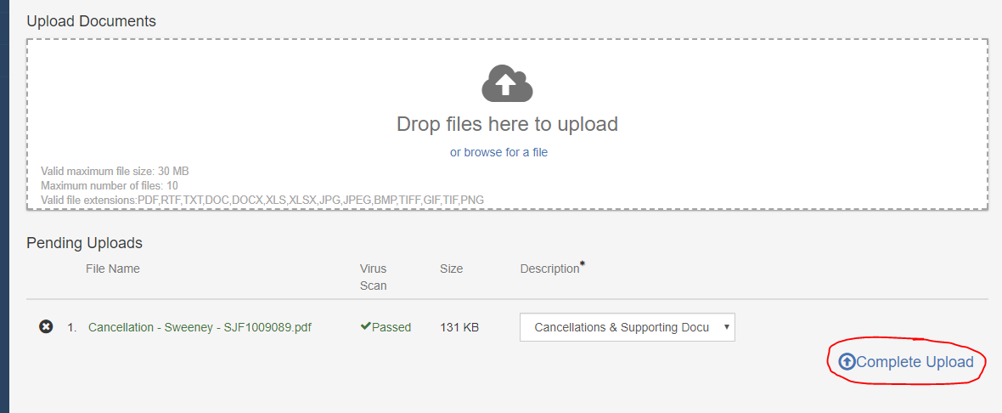

Florida Family Flood
- For Florida Family Flood, please refer to the Bankers Flood section of this SOP for uploading documents.

Foremost Insurance Company
- For Foremost Insurance, please refer to the Email from AMS section of this SOP as you cannot upload documents to their website.
- The email address to send to this carrier is imaging@foremost.com.

Frontline Insurance
- For Frontline Homeowner, click on the Policy Search button.
- 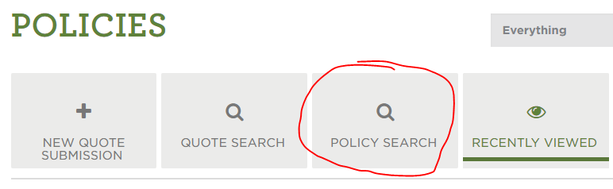
- Enter policy number.
- Click on the Search button.
- 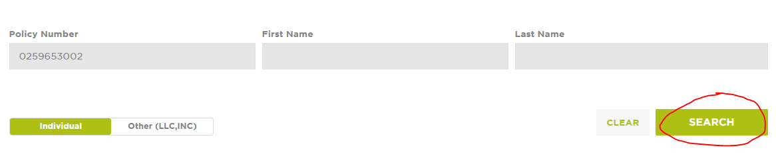
- Click on the policy number link.
- 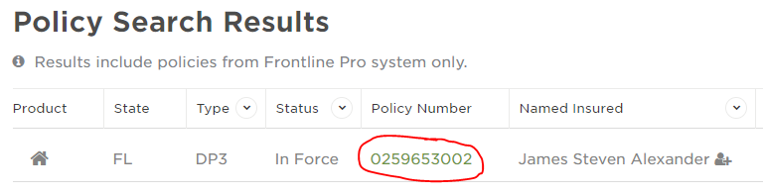
- Click on the Documents tab.
- 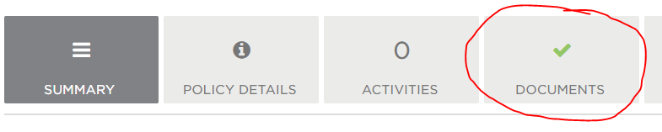
- Select the Policy Documents tab.
- 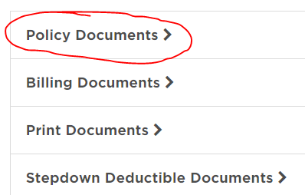
- Click on the Select Documents to Upload button.
- 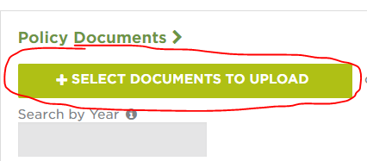
- Select the correct document.
- Click on the Open button.
- 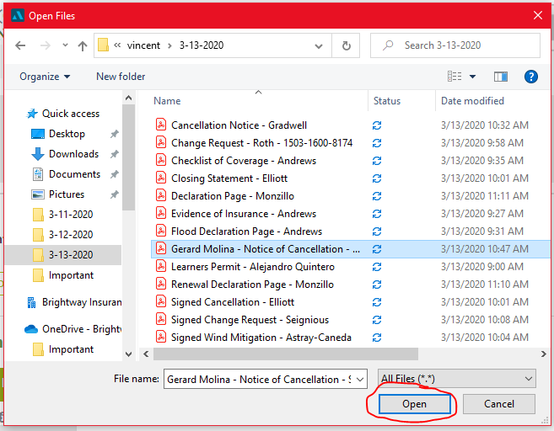

Frontline Flood
- For Frontline Flood, please refer to the Bankers Flood section of this SOP for both uploading documents.

GeoVera Specialty Insurance
- For GeoVera Insurance, please refer to the Email from AMS section of this SOP as you cannot upload documents to their website.
- The email address to send to this carrier is info@geoveraadvantage.com.

Germania Homeowners
- For Germania Insurance, enter policy number.
- Click on the magnify glass.
- 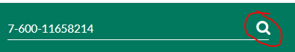
- Click on the Documents Photos button.
- 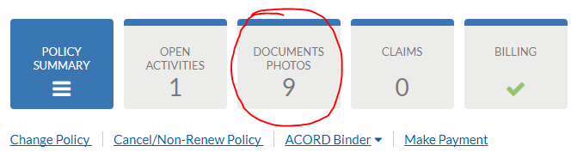
- Click on the Upload Files.
- 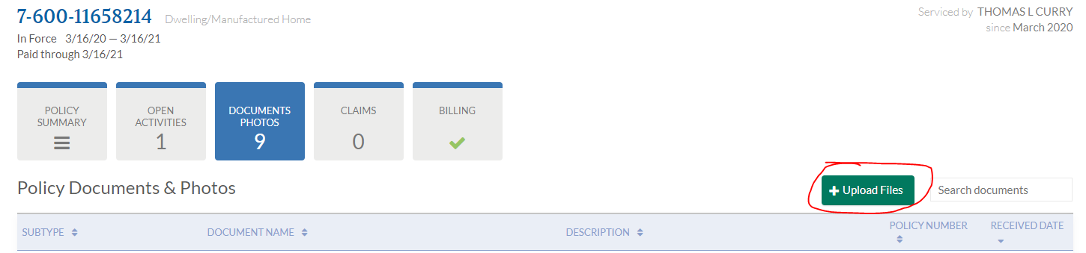

Grundy Worldwide
- For Grundy Worldwide, please refer to the Email from AMS section of this SOP as you cannot upload documents to their website.
- The email address to send to this carrier is collectorvehicle@grundy.com.

Gulfstates Homeowners
- For Gulfstates Insurance, please refer to the Homeowner’s of America section of this SOP.

Gulfstates Flood
- For Gulfstates Flood Insurance, please refer to the Bankers Flood section of this SOP.

Gulfstream Flood
- For Gulfstream Flood, please refer to the Bankers Flood section of this SOP for both upload documents.

Gulfstream Homeowner
- For Gulfstream Homeowner, please refer to the Email from AMS section of this SOP as you cannot upload documents to their website.
- The email address to send to this carrier is csr@gulfstreampsc.com.

Hagerty Insurance
- For Hagerty Insurance, hover over Insurance.
- Click on Manage Policies.
- 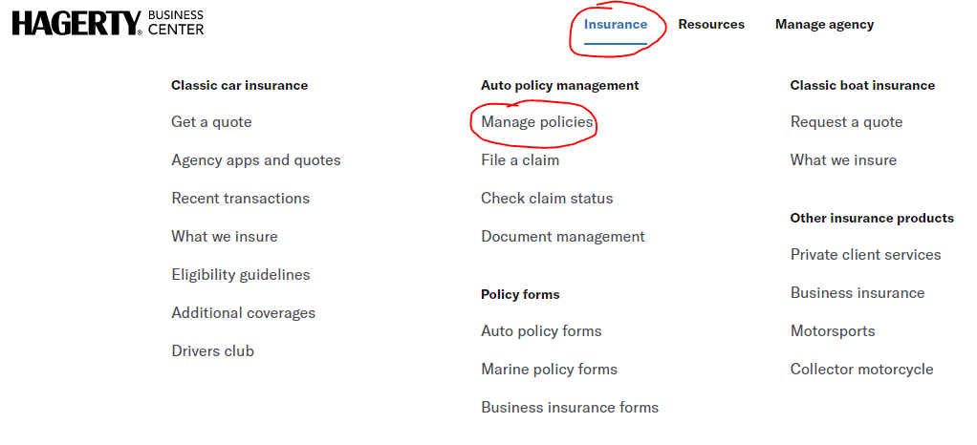
- Enter the policy number.
- Click on the Apply Filter button.
- 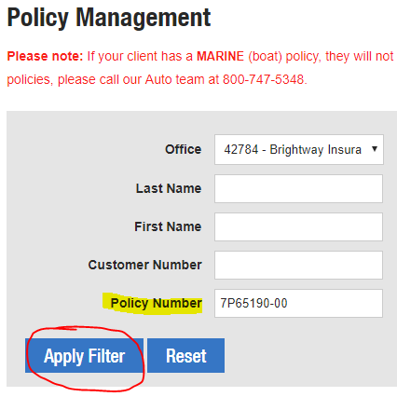
- Click on the View button.
- 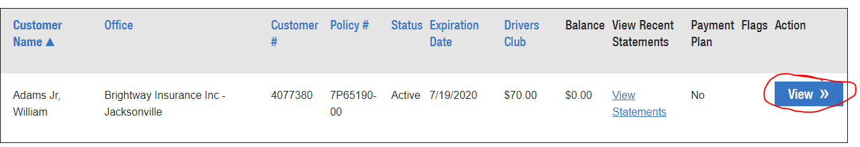
- Click on the Upload a Document or Photo link.
- 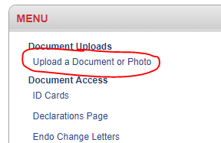
- In the drop-down menu, select the appropriate upload type.
- Click on the Choose File button.
- 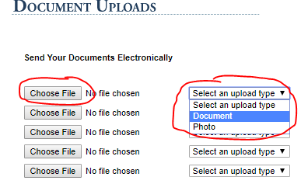
- Select the correct document.
- Click on the Open button.
- 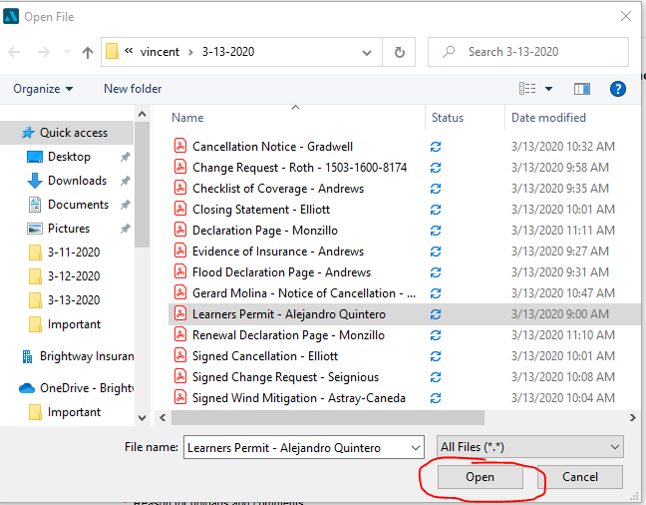
- Enter the information that has the red asterisk symbol next to it.
- Click on the Upload button.
- 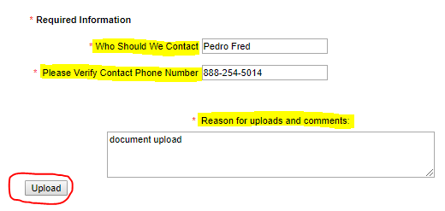

Hartford Insurance
- For Hartford, please refer to the Email from AMS section of this SOP as you cannot upload documents to their website.
- The email address to send to this carrier is piagencyservice@thehartford.com.

Heritage Property and Casualty Insurance Company
- For Heritage, click on the Policy Administration button.
- 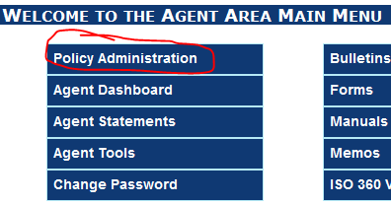
- Enter in the policy number in the Policy # or Last Name box.
- Click on the Quote/Policy Search.
- 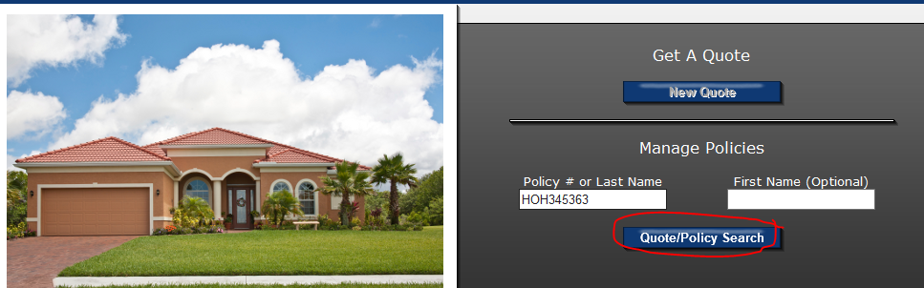
- Select the desired term by clicking on the policy number link under Policy ID.
- 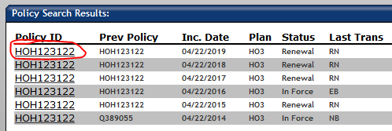
- Click on the Document Upload link.
- 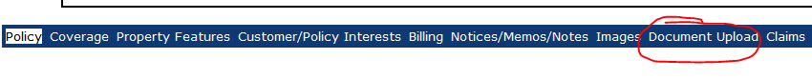
- Click on the Browse button.
- Click on the Upload Files button.
- 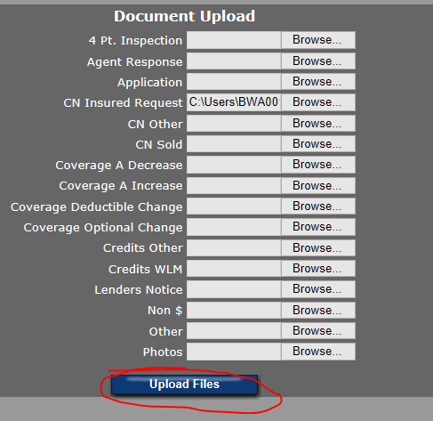

Hippo Insurance
- For Hippo, please refer to the Email from AMS section of this SOP as you cannot upload documents to their website.
- The email address to send to this carrier is support@myhippo.com.

Homeowners Choice Insurance
- For Homeowners Choice, please refer to the Email from AMS section of this SOP as you cannot upload documents to their website.
- The email address to send to this carrier is customerservice@hcpci.com.

Homeowner’s of America
- For Homeowner’s of America, please refer to the Email from AMS section of this SOP as you cannot upload documents to their website.
- The email address to send to this carrier is customerservice@hoaic.com.

I.B. Green & Associates Insurance
- For I.B. Green & Associates Insurance, click on the Portal button.
- 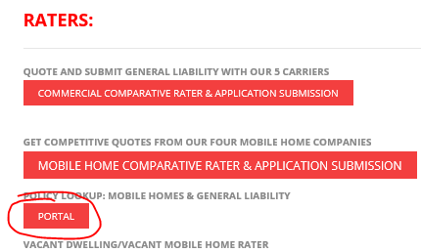
- Click on the Policy tab.
- 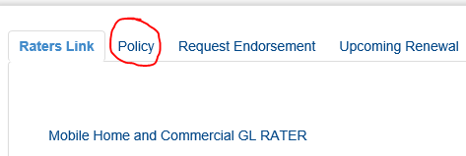
- Select 1 Year.
- 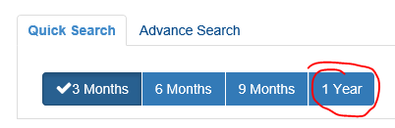
- Enter the policy number.
- 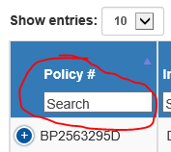
- Click on the Documents tab.
- Click on the [+] Upload Document link.
- 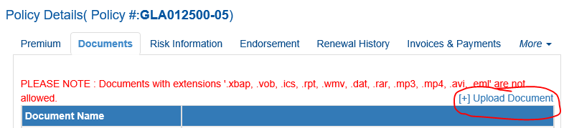
- Drag the file into the browser.
- Click on the Submit button.
- 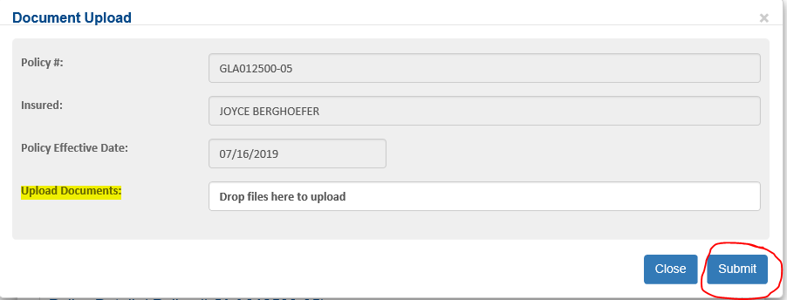

Infinity Insurance (Kemper Personal and Specialty)
- For Infinity, enter in the policy number in the Policy Search box.
- Click on the magnify glass.
- 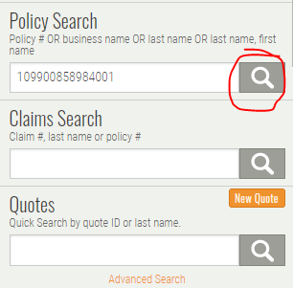
- Click on the Upload Documents button.
- 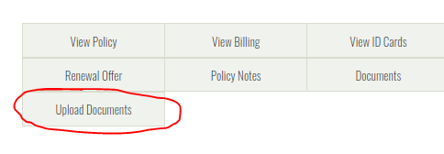
- Select the reason.
- Click on the Next – Add Documents button.
- 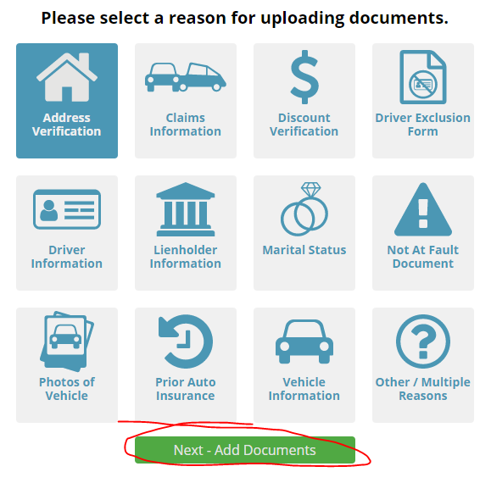
- Click on the Select Documents button.
- Click on the Upload Documents button.
- 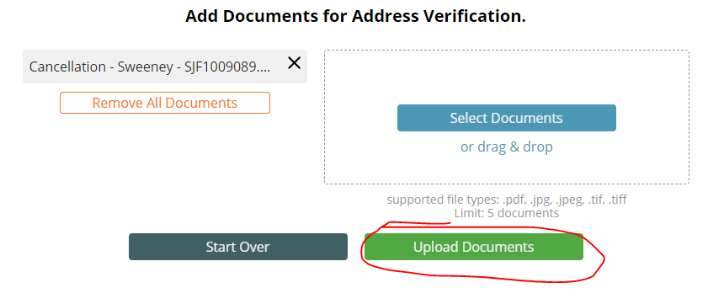
- Click on the Finish button.
- 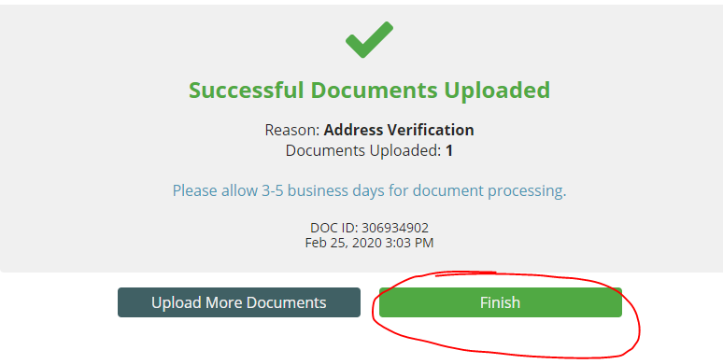

Auto Cancellation Process
- Once cancellation has been signed and sent back to us for this carrier, click on the View Billing button.
- 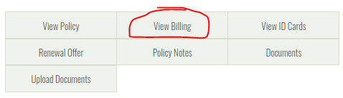
- Click on the AutoPay button on the left side.
- 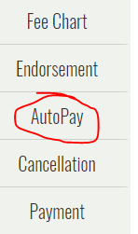
- Enter the effective date of cancellation.
- Deselect the AutoPay.
- Enter your name.
- Click on the Submit button.
- 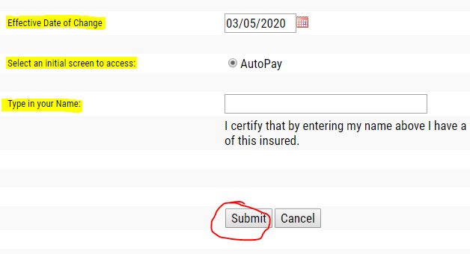
- Click on the Cancellation button on the left side.
- 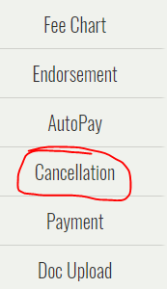
- Enter your name.
- Enter the cancellation effective date.
- In the Reason drop-down, select reason for cancellation.
- Select the vehicle(s).
- Click on the Process button.
- 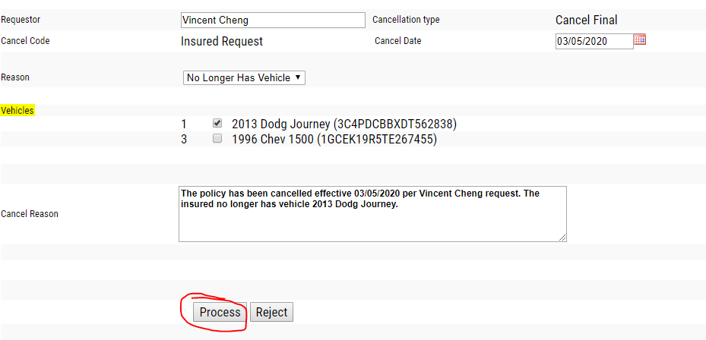

Kansas Fair Plan
- For Kansas Fair Plan, please refer to the Anchor Insurance section of this SOP.

Lighthouse Homeowners
- For Lighthouse Insurance, all the policies are under the Diamond login.
- Enter policy number.
- Click on the magnify glass icon.
- 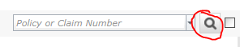
- Select the Attachments tab.
- Select the document type in the Type drop-down menu.
- Click on the Browse button.
- 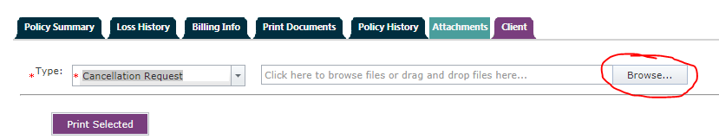
- Click on the Add button.

Lighthouse Flood
- For Lighthouse Flood, please refer to the Bankers Flood section of this SOP.

Maison Homeowner
- For Maison Homeowner, please refer to the Prepared Insurance section of this SOP for uploading documents.

Maison Flood
- For Maison Flood, please refer to the Bankers Flood section of this SOP for uploading documents and phone payment process.

Mercury Insurance Group
- For Mercury, enter in the policy number in the Search by box.
- Click on the green Go button.
- 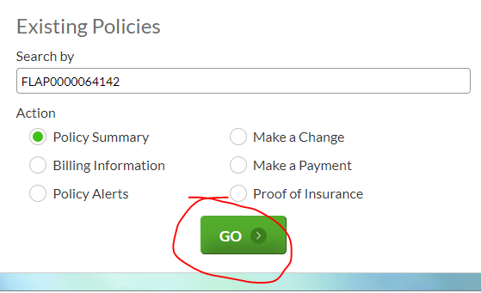
- Click on the Upload button.
- 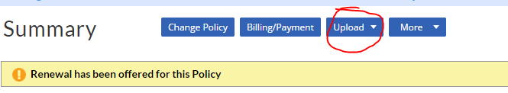
- Select Upload – Other than Required Document(s).
- 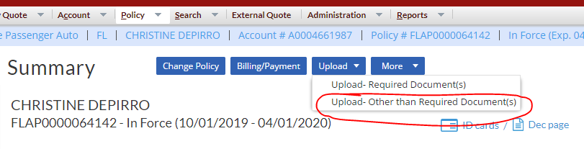
- Click on the green Browse button.
- 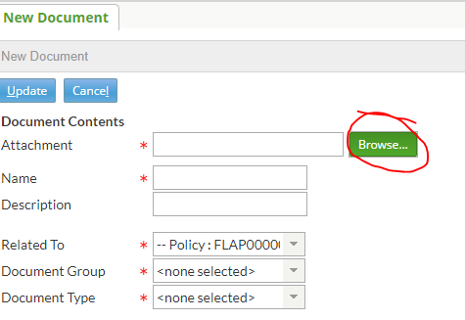
- In the drop-down menu for Document Group, select the appropriate document reason.
  - It will auto fill for the Document Type.
- Click on the Update button.
- 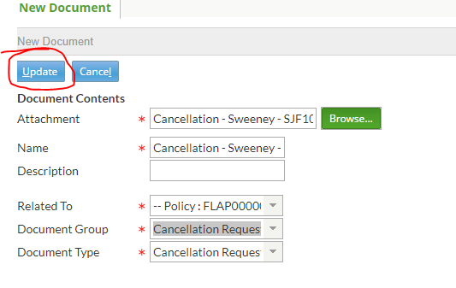
- IMPORTANT
- Once cancellation has been signed and sent back to us for this carrier, to cancel EFT: Email mercury accounting autopay@mercuryinsurance.com – the EFT cancellation process is 3 days from the date the email is sent.

Narragansett Bay Homeowners
- For Narragansett Bay Insurance, please refer to the Email from AMS section of this SOP as you cannot upload documents to their website.
- The email address to send to this carrier for billing inquiries and any other general correspondence (such as non-payment cancellation requests) is customerservice@nbic.com.
- The email address to send to this carrier for underwriting related documents is asg@nbic.com.

National General Insurance
- For National General, enter in the policy number in the Find Customer box.
- Click on the Search button.

- 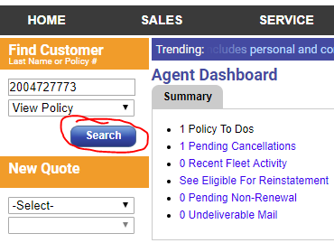
- Select the desired term by clicking on the policy number ink under the Policy section.
- 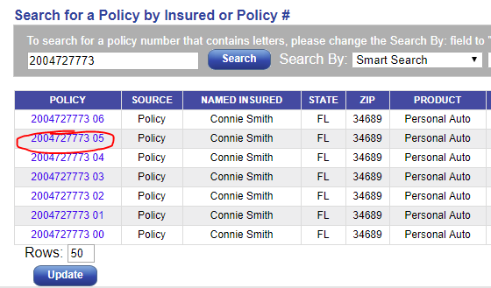
- Click on the Upload + link.
- 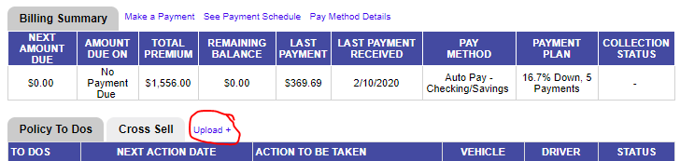
- Click on the Choose Files button.
- Click on the Submit button.
- 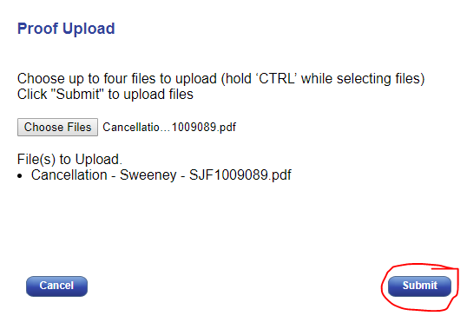
- The Uploaded Documents tab will be available if there was none before uploading the document.
- 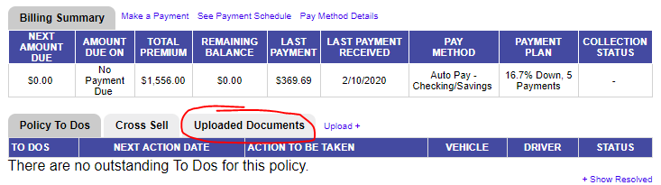

Auto Cancellation Process
- Once cancellation has been signed and sent back to us for this carrier, click on Update Billing Info link.
- 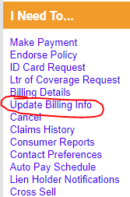
- Select Change Payment Method/Payment Plan.
- 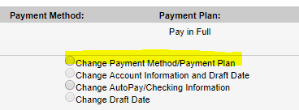
- In the New Payment Method drop-down, select Direct Bill.
- 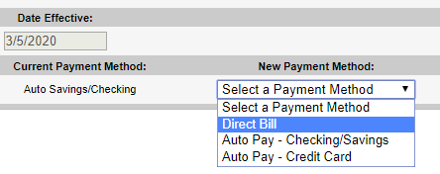
- Click on the Cancel link.
- 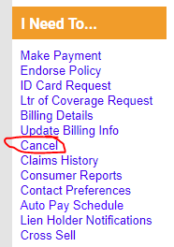
- In the Cancellation Reason drop-down, select Insured’s Request.
- In the Request Reason drop-down, select the appropriate reason for cancellation.
- Enter cancellation effective date in the Effective Date box.
- In the Producer drop-down, select Pedro A Fred.
- Click on the Continue button.
- 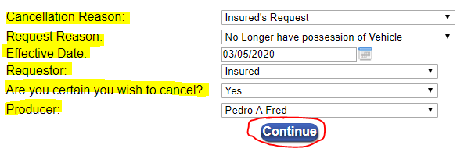
- Click on the Continue button once you have selected both boxes.
- 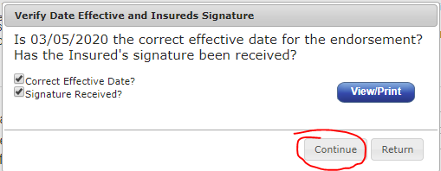
- Click on the Submit button.
- 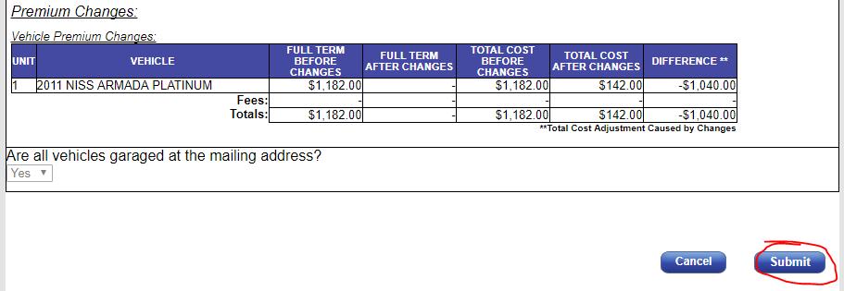

Neptune Flood
- Please refer to the American Traditions Homeowner section of this SOP for uploading documents and phone payment process.

NFIP Insurance
- For NFIP, please refer to the Bankers Flood section of this SOP for uploading documents and phone payment process.

Olympus Homeowner
- For Olympus, click on the Search link.
- 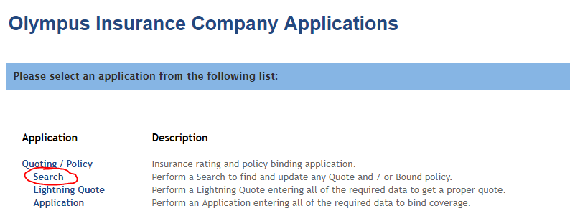
- Enter in the policy number in the Policy/Quote Number box.
- Click on the Search button.
  - NOTE: Make sure to add the hyphen before the last two numbers.
- 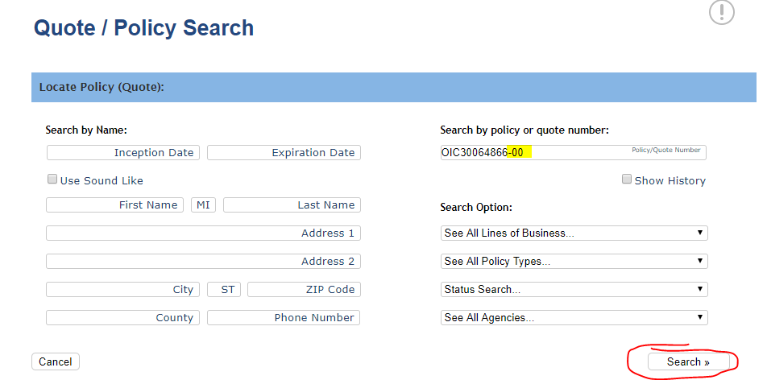
- Click on the Documents tab.
- Click on the Add Attachment button.
- 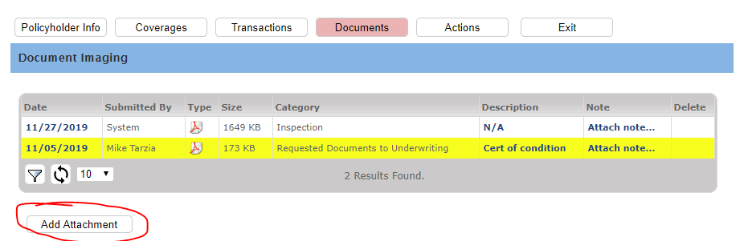
- In the Category drop-down menu, select the appropriate reason.

- 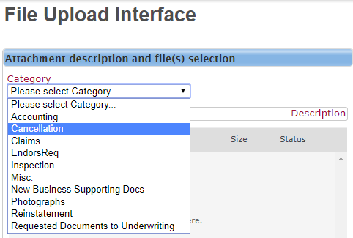
- In the description, type in “Please process this request.”
- Click on the Add Files button.
- Click on the Start Upload button.
- 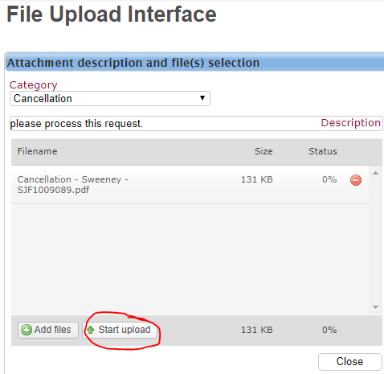

Olympus Flood
- For Olympus Flood, please refer to the Bankers Flood section of this SOP for uploading documents.

Peoples Trust Insurance Company

- Must be completed on the carrier’s form if backdating

  - • Names must match carrier’s website
  - o Both named insureds must sign the form

- Will only backdate 7 days without a closing statement

- Call Peoples Trust when the cancellation form has been uploaded

- For People’s Trust, enter in the policy number in the search box.
- Click on the magnify glass.

- 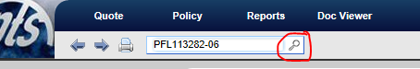
- Click on the Activity link on the left side.
- Click on the Attachment link in the Attachments section.
- 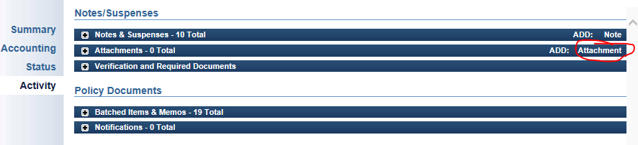
- Click on the + Select Files button.
- 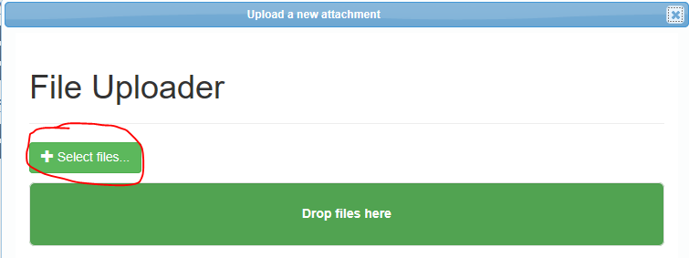
- Click on the Update button.
- 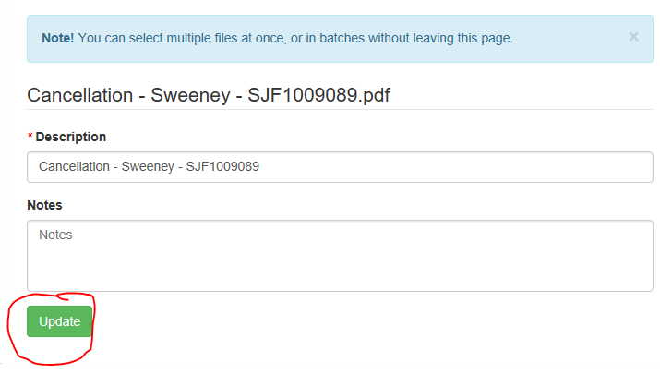

Prepared Homeowner
- For Prepared Homeowner, type in the policy number in the Policy/Quote ID box.
- Click on the Go button.

- 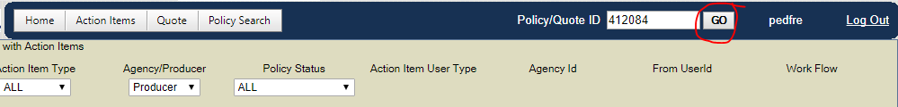
- Click on the Docs/Fax button.
- 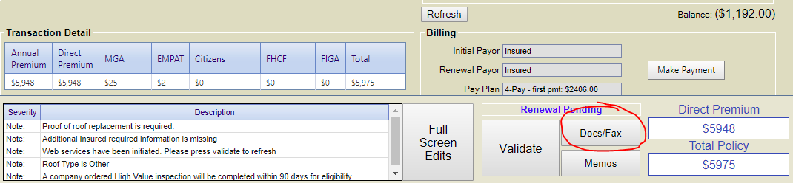
- Select the correct document description.
- In the comments box, type “Please process this request.”
- 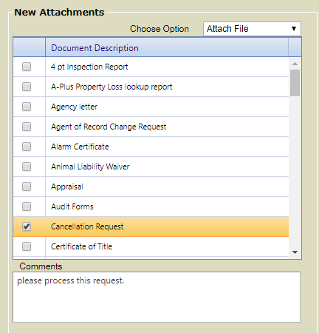
- Click on the Choose Files button.
- 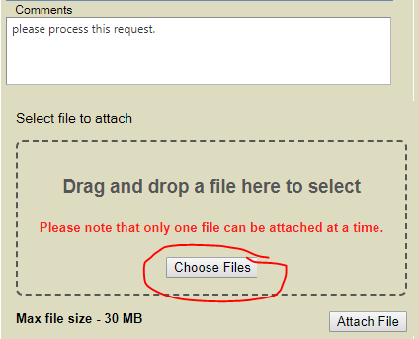
- Click on the Attach File button.
- 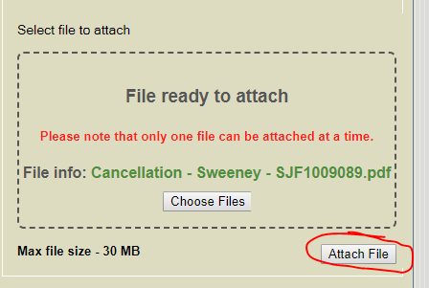

Prepared Flood
- For Prepared Flood, please refer to the Bankers Flood section of this SOP for uploading documents.

Progressive American Insurance Company
- For Progressive, please refer to the Email from AMS section of this SOP as you cannot upload documents to their website.
- The email address to send to this carrier is upload@progressiveagent.com.

PURE Flood
- For PURE Flood, please refer to the American Bankers section of this SOP for uploading documents.

Safepoint Insurance
- For Safepoint, please refer to the Email from AMS section of this SOP as you cannot upload documents to their website.
- The email address to send to this carrier is underwriting@safepointins.com.

Safe Harbor Insurance Company
- For Safe Harbor, you would login to the Cabrillo Coastal site.
- Click on the Policy Review link on the left side.
- 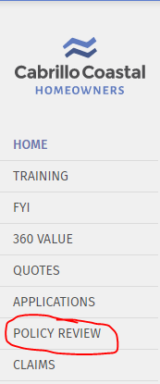
- Enter in the policy number in the Policy Number box.
- Click on the magnify glass.
- 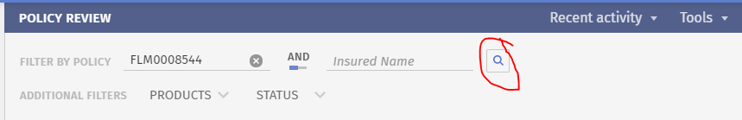
- Click anywhere near the policy number.
- Click on the View button.
- 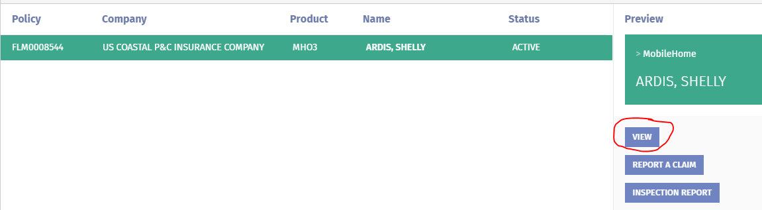
- Click on the Document Upload link.
- 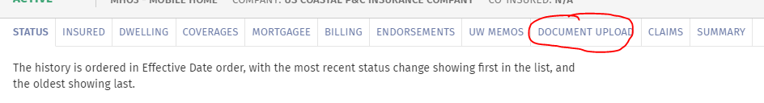
- Click on the Select File button.
- For cancellations, in the Document Category drop-down menu select Cancellation.
- 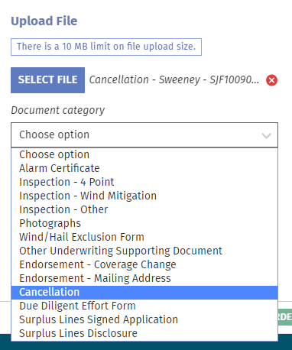
- Click on the Upload button.
- 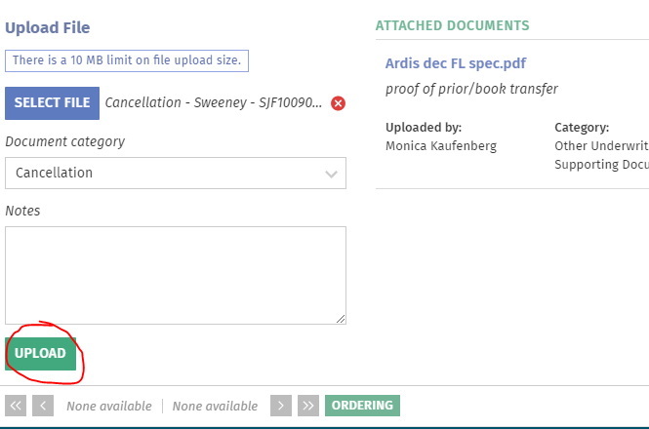

Safeco
- For Safeco, attach the signed cancellation to AMS as this carrier is self-service.
- Label the Activity as Cancellation Request.
- In the description, type in “Signed cancellation request.”
- Click on the Save and Close button on the top left.
- 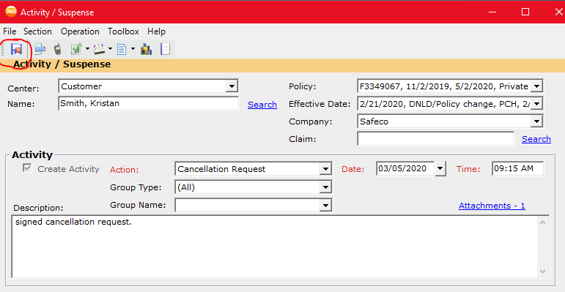

Auto Cancellation Process
- Once cancellation has been signed and sent back to us for this carrier, enter in the policy number in the search box.
- Click on the magnify glass icon.

- Click on the Decision tab.
- 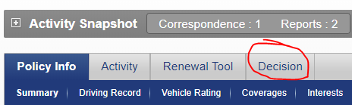
- Enter in the cancellation effective date in the Cancel Date box.
- Type in the Cancel Reason box a brief description of the reason for cancellation.
- Click Submit.
- 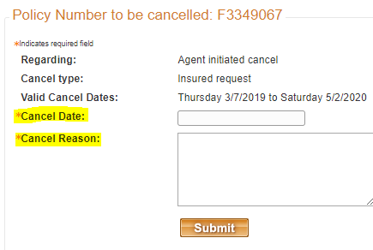

SageSure Homeowner
- For Sagesure Insurance, please refer to the Email from AMS section of this SOP as you cannot upload documents to their website.
- The email address to send to this carrier is policyservices@sagesure.com.

SageSure Flood
- For SageSure Flood, please refer to the American Bankers section of this SOP for uploading documents.

Seacoast Brokers Insurance
- For Seacoast Brokers, click on the Agent Resources tab.
- 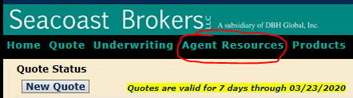
- Click on the Cancel Policy link.
- 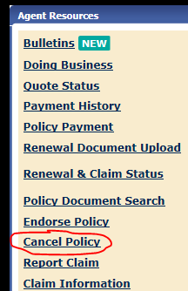
- If making endorsement request, click on the Endorse Policy link.
- 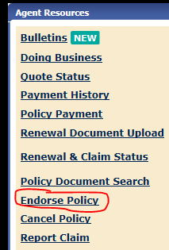
- Enter the policy number.
- Click on the Find button.
- 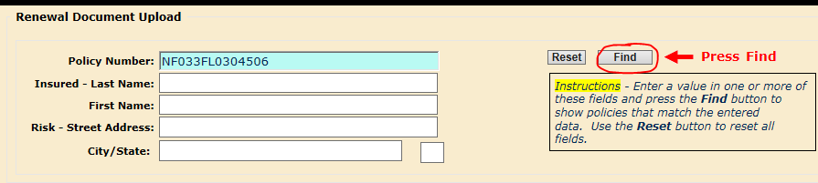
- Enter Effective Date as the cancellation effective date.
- Select Cancellation Type in the drop-down menu.
- Click on the Browse button.
- Click on the Upload button.
- Click on the Submit button.
- 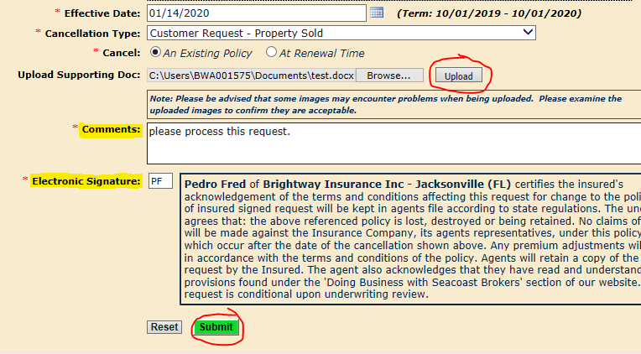

Security First
- For Security First, click on the Access CARINA button.
- 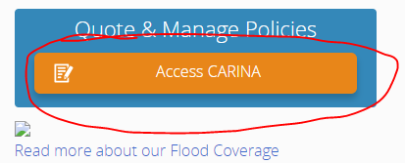
- Select the Reference Number bubble.
- Enter the policy number in the Reference Number box.
- Click on the Search button.
- 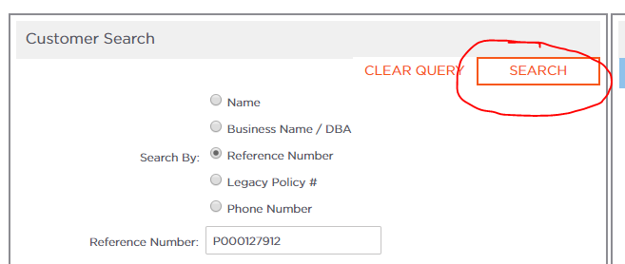
- Click on the policy number link under the Reference Number section.
- 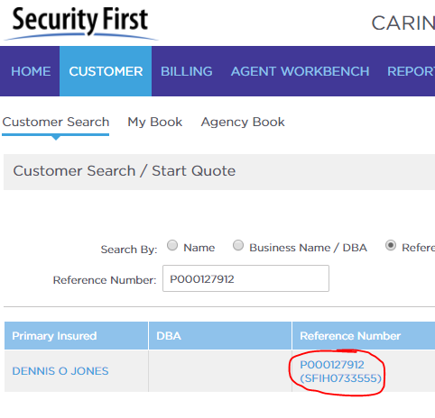
- Click on the Upload Attachment link.
- 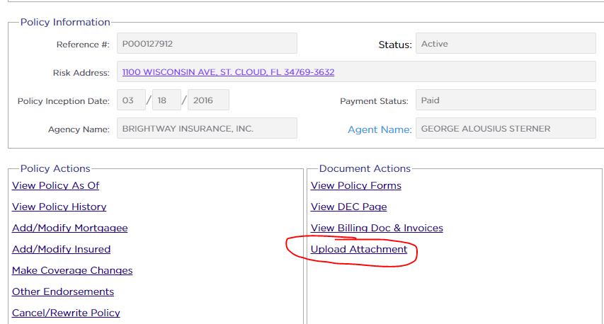
- Click on the Attach File icon.
- 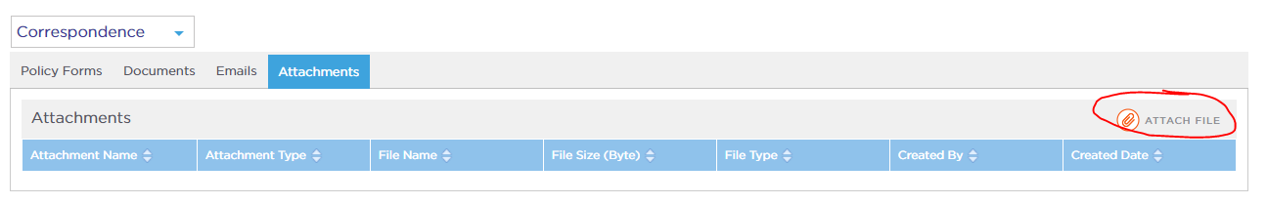
- Click on the + Add button.
- 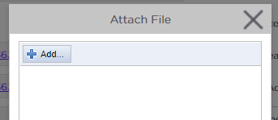
- Once you have uploaded the document, also notify them via email that you have uploaded documents to their site.
- 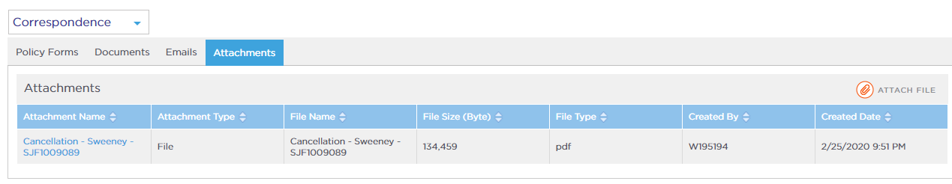

Ski Safe Watercraft
- For Ski Safe Watercraft Insurance, please refer to the Email from AMS section of this SOP as you cannot upload documents to their website.
- The email address to send to this carrier is customer@skisafe.com.

Southern Insurance Underwriters
- For Southern Insurance, For Travelers, please refer to the Email from AMS section of this SOP as you cannot upload documents to their website.
- The email address to send to this carrier is lthomas@siuins.com.

Southern Oak Insurance Company
- For Southern Oak, click on the Workbench icon.
- 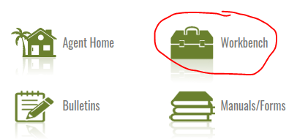
- Click on the Book of Business tab.
- Click on the gear icon.
- 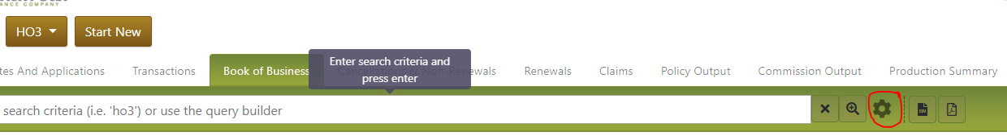
- Click on Agent in the Search by Section.
- 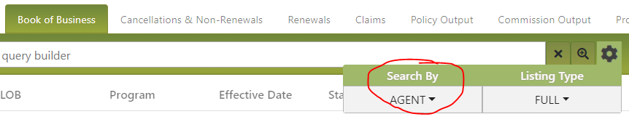
- Select Master Agency.
- 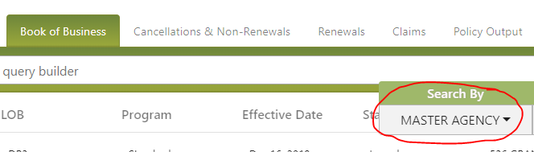
- Enter the policy number in the search box.
- Hit Enter on your keyboard.
- 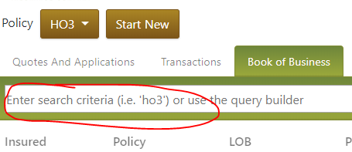
- Click anywhere near the policy number.
- 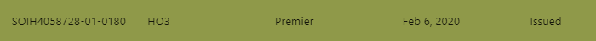
- Hover over the Actions tab on the right side.
- 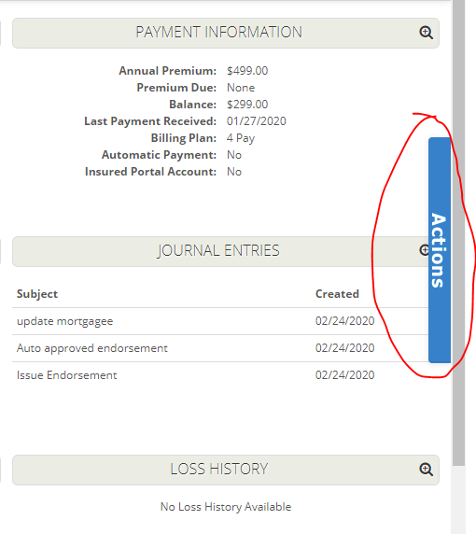
- Under the Communication section, click on the Upload Documents link.
- 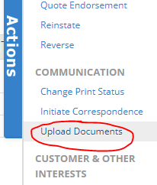
- Click on the empty box.
- 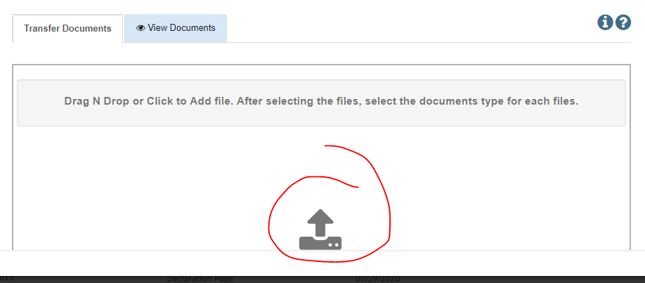
- For cancellations, select Cancellation in the Document Type drop-down menu.
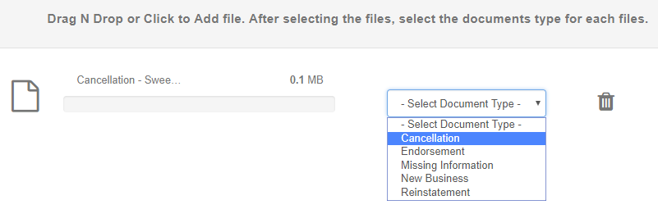
- Click on the Upload File(s) button.
- 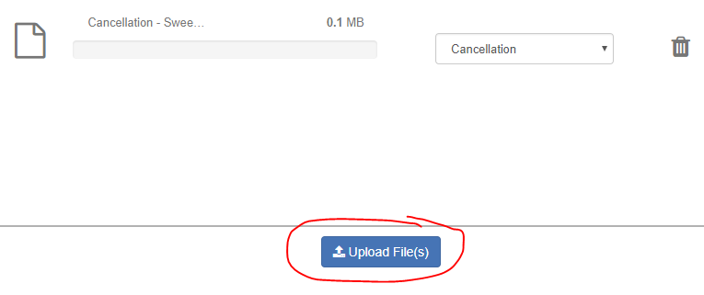

Stillwater Homeowner
- For Stillwater Insurance, please refer to the Email from AMS section of this SOP as you cannot upload documents to their website.
- The email address to send to this carrier is ins@stillwaterinsurance.com.

St. Johns Insurance Company
- For St Johns, please refer to the Email from AMS section of this SOP as you cannot upload documents to their website.
- The email address to send to this carrier is underwriter@sjicsips.com.

State Auto
- For State Auto Insurance, enter policy number.
- Click on the magnify glass icon.
- 
- Click on the policy number link.
- 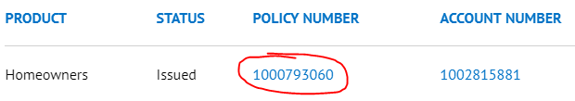
- Select the Documents tab.
- 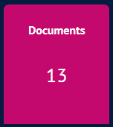
- Scroll down and click on the Upload Documents button.
- Select Send to Company Only.
- 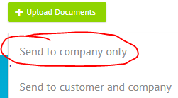

Tapco Insurance
- For Tapco, please refer to the Email from AMS section of this SOP as you cannot upload documents to their website.
- The email address to send to this carrier is endorsements@gotapco.com.

Texas Fair Plan
- For Texas Fair Plan, please refer to the Email from AMS section of this SOP as you cannot upload documents to their website.
- The email address to send to this carrier is TFPAPolicy@twia.org.

The Hartford
- For Hartford, please refer to the Email from AMS section of this SOP as you cannot upload documents to their website.
- The email address to send to this carrier is piagencyservice@thehartford.com.

Auto Cancellation Process
- Once cancellation has been signed and sent back to us for this carrier, click on the Manage Policies button.
- 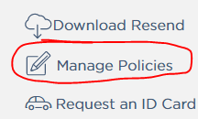
- Enter the policy number and click on the Search button.
- 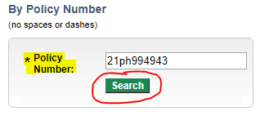
- Enter cancellation effective date in the Effective Date boxes.
- Click on the Cancel Policy button.
- 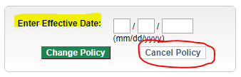
- Enter the Cancellation Effective Date.
- Select the reason for cancellation in the Cancellation Reason drop-down.
- Select Yes.
- Click on the Review Changes button.
- 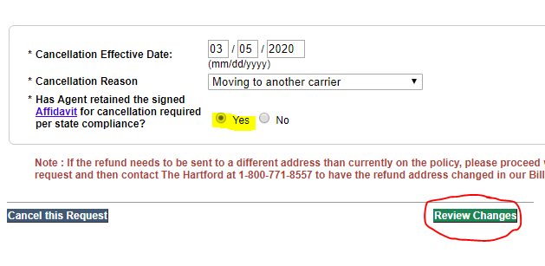
- Click on the Proceed with Cancellation button.
- 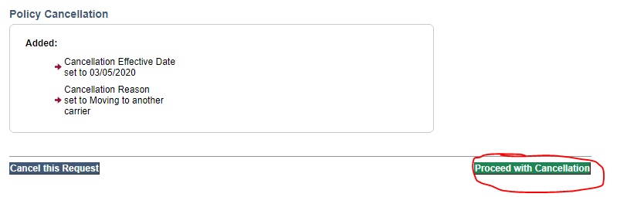

Tower Hill Insurance
- For Tower Hill, Click on the Personal Lines Portal button.
- 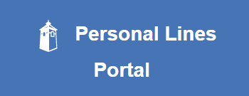
- Enter the policy number in the Policy # box.
- Click on the Search button.
- 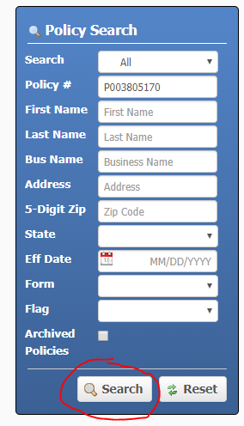
- Select the desired term by clicking on the policy number link under the Policy # section.
- 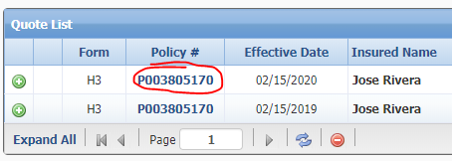
- Click on the Documents button.
- 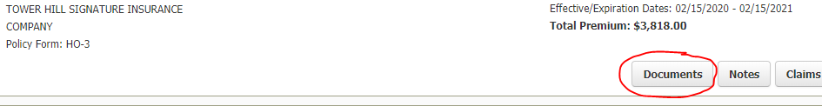
- Scroll all the way down.
- Click on the + Upload Document button.

- 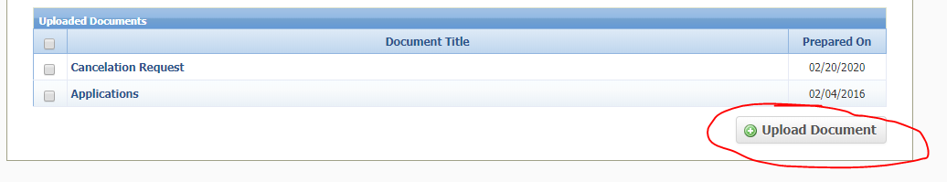
- For cancellations, select Cancelation Request in the Document Title drop-down menu.
- 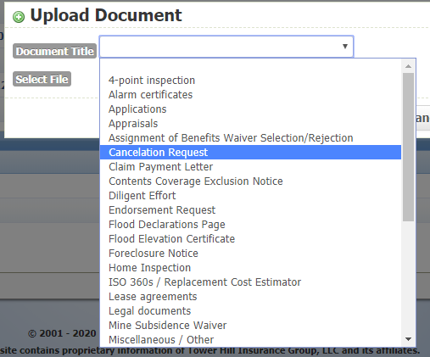
- Click on the Choose File button.
- Click on the Upload button.
- 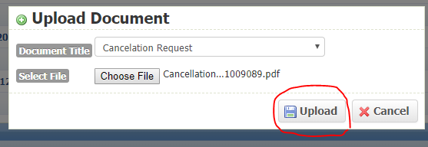

Travelers
- For Travelers, please refer to the Email from AMS section of this SOP as you cannot upload documents to their website.
- The email address to send to this carrier is piservice@travelers.com.

TypTap Insurance
- For both TypTap Homeowner and Flood, please refer to the Email from AMS section of this SOP as you cannot upload documents to their website.
- The email address to send to this carrier is customerservice@typtap.com.

Universal Insurance Company of North America
- For Universal Insurance Company of North America, click on the Policy/Customer Search link.
- 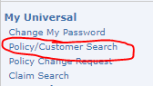
- Enter the policy number in the Policy Number box.
- 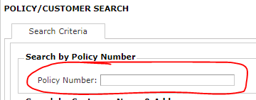
- Click on the Search button.
- 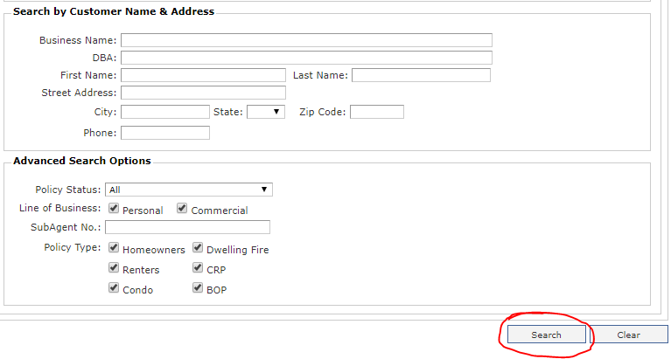
- Click on the View link.
- 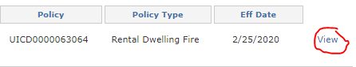
- Click on the Request a Change button.
- 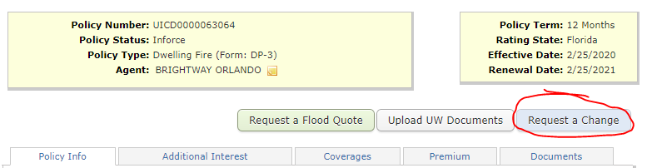
- For cancellations, enter in the effective date of cancellation in the Effective Date of Change boxes.
- Type in your name in the Submitter Name box.
- Click on the drop-down menu for the next box.
- Select Cancel Policy.
- In the Reason drop-down menu, select Property Sold if the reason is for the property being sold.
- In the next box, type in “Please process this request.”
- 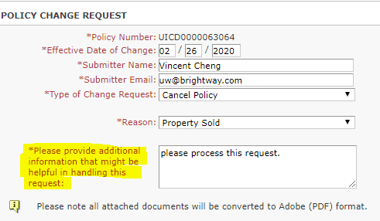
- In the Document Type drop-down menu, select Property Correspondence for the cancellation request and select Settlement Statement for the settlement statement.

- 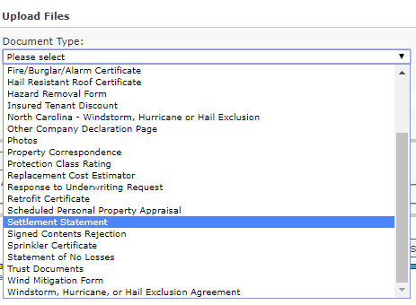
- Click on the Choose File button.
- Click on the Attach Document button.
- Click on the Submit Change button when all documents have been attached.
- 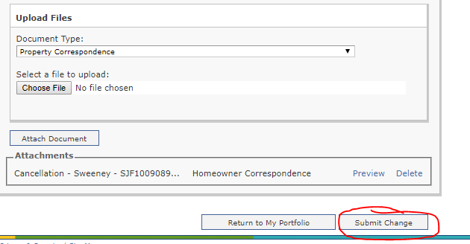

Universal Property and Casualty
- For Universal Property and Casualty, hover over the Policies tab.
- Select Policy Search.
- 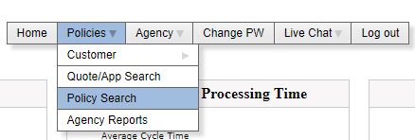
- Click on the Document Uploads link.
- 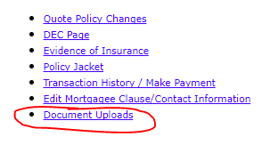
- For cancellations, select Cancellation Request in the Document Type drop-down menu.
- 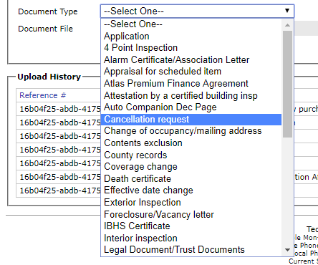
- Click on the Choose File button.
- 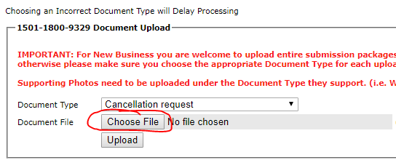
- Click on the Upload button.
- 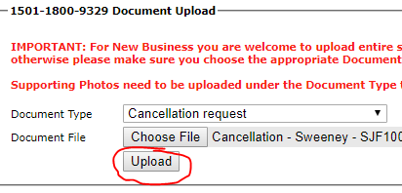
- Once you have uploaded the document, also notify them via email that you have uploaded documents to their site.

Velocity Risk Underwriters
- For Velocity, type in the policy number in the Policy/Quote # box.
- Click on the Go button.
- Click on the Docs/Fax button.
- 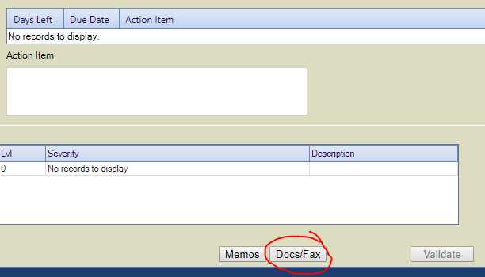
- Select the correct document description.
- In the Comments box, type please process this request.
- 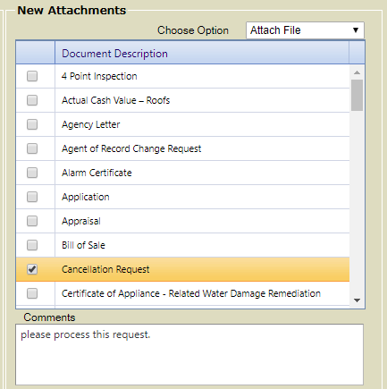
- Click on the Choose Files button.
- Click on the Attach File button.
- 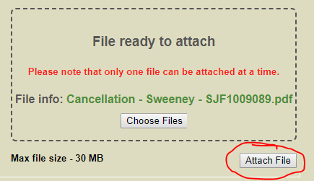

Wellington Insurance
- For Wellington Insurance, please refer to the Email from AMS section of this SOP as you cannot upload documents to their website.
- The email address to send to this carrier is personallines@wellingtoninsgroup.com.

Weston Insurance
- For Weston, please refer to the Email from AMS section of this SOP as you cannot upload documents to their website.
- The email address to send to this carrier is policyservices@weston-ins.com.

Windhaven Insurance
- For Windhaven, please refer to the People’s Trust Insurance section of this SOP for uploading documents.

Wright Flood
- For Wright Flood, enter the policy number in the Policy Number / Name box.
- Click on the magnify glass.
- 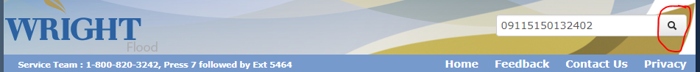
- Click on the File Upload link on the left side.
- 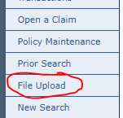
- Click anywhere on the box to upload file.
- Click on the Upload Files button.

